

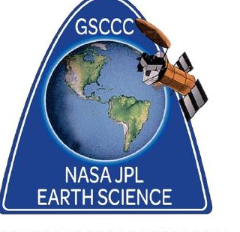
NASA / JPL EARTH SCIENCE
Council’s Own Patch Program

Explore our amazing planet through the eyes of NASA and JPL! Learn how scientists study Earth’s climate, oceans, weather and other systems from both the ground and space and discover how they use that information to better understand our changing world. Then explore ways you can help protect our planet and make a difference in your own community.

Once you complete the curriculum, please purchase your patch through DoubleKnot

Patch cost $5.00 includes shipping.

Welcome to Planet Earth!
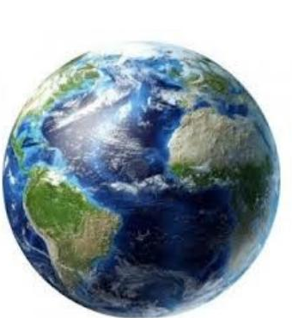
This Patch Program has been designed by our friends at JPL / NASA in Pasadena, California for Girl Scouts to learn about our amazing Planet Earth.
Most Girl Scouts know that JPL builds rovers and NASA sends astronauts into space. Did you know that NASA and JPL also keep an eye on our home planet, Earth? Understanding Earth from the viewpoint of space helps us to understand and connect to our changing world. NASA monitors the vital signs of Earth from the perspective of space to help you understand the future of your planet, to help you connect to your changing world and to your global community.
In this Patch Program, we will be exploring the Earth's Systems through temperature, climate and ocean systems using on-line platforms and then you will be asked to Take Action in your own community to implement projects that bring these explorations home to your own backyard, here on Planet Earth!

To earn this patch, please complete the following number of items from each section:
Level | Discover | Connect | Take Action
Daisy | 1 | 1 | 1
Brownie | 2 | 1 | 1
Junior | 2 | 2 | 1
Cadette | 2 | 2 | 2
Senior | 3 | 2 | 2
Ambassador | 3 | 3 | 2

DISCOVER, YOUR EARTH'S SYSTEMS

1. Measuring Air Temperature
- Using an outdoor thermometer, take the air temperature (about 3 feet above the ground) every morning and evening at approximately the same time for 10 consecutive days.
- Take multiple temperature readings from at least six locations (such as in the shade, in the sunshine, your front yard, your back yard, above concrete, and above grass).
- Write down the temperatures in each location and the weather conditions as you recorded the temperatures.
- Report your findings to your troop.
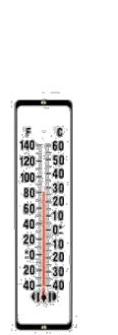
2. Understanding Temperature Differences
- You will need to use a newspaper, an online weather website, or the weather report from the news on TV for this activity.
- Pick two cities in the United States which are at similar latitudes – one along the coast and one inland (for example: Denver, Colorado and Baltimore, Maryland are both at 39° north latitude).
- Record the high and low temperatures in each city for 10 consecutive days.
- Write a short summary of the temperature differences.
A list of latitudes of major U.S. cities can be found at: http://www.artscipub.com/info/latlonofmajorcities.asp
3. Heat Capacity Of The Ocean
- Watch the “Oceans of Climate Change” video https://science.nasa.gov/resource/video-oceans-of-climate-change/ (less than 4 minutes).
- Use the instructions that were demonstrated to recreate the experiment. You will need an adult or a troop leader to help you with this activity.
- During your own experiment, record the time it took for each balloon to pop.
- What do you think is causing the difference?
4. NASA/JPL Takes the Earth's Vital Signs
- Visit the Eyes on the Earth website.
- Choose 5 NASA satellites that are currently monitoring our planet, Earth.
- Which satellites look at the ocean? Land? Atmosphere?
- Which satellite is the smallest? Which is the largest?
Eyes on the Earth: http://eyes.nasa.gov/earth/download.html
(Please note that this website interface does not work on iPads)
5. Earthquakes
- Take a look at the most current earthquakes which have happened around the world at: http://earthquake.usgs.gov/earthquakes/map/
- Where do you see the most earthquakes?
- Why do you think this is the case?
For clues, check out the Ring of Fire at the following website: http://www.weatherwizkids.com/weather-volcano.htm
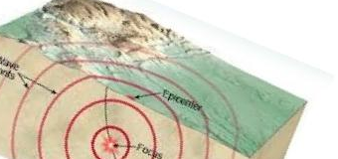
6. Sea Level Rise
- Find two clear plastic cups.
- With a permanent marker, label one cup "Sea Ice" and the other cup "Land Ice."
- Fill each cup with water.
- Add a large ice cube to the cup labeled "Sea Ice."
- Mark the water level with a permanent marker.
- Place a piece of cheesecloth (you can substitute with aluminum foil or plastic wrap with small holes poked into it) on the top of the cup labeled "Land Ice."
- Secure the cheesecloth, foil or plastic wrap with a rubber band around the top of the cup.
- Place a large ice cube on top of the cheesecloth, foil or plastic wrap.
- Once the ice melts, mark the water level with permanent marker.
- Which cup had the largest amount of increase in the water level? Why?
For more information visit the following website: http://www.calacademy.org/explore-science/a-warming-planet

- Land ice, such as glaciers and ice sheets found on Greenland and Antarctica, raises sea level as it melts. This happens because, when ice on land melts, it adds water into the ocean that was not there before.
- Sea ice, such as ice shelves and icebergs, do not raise sea level. According to Archimedes' principle, a floating object dislocates an amount of water equal to its weight. Therefore, when floating ice melts, there is very little change in sea level.
7. Clouds
- Make a cloud mobile by following the instructions at: https://spaceplace.nasa.gov/cloud-mobile/en/
- What is your favorite type of cloud?
- Are they high up in the atmosphere or close to the ground?

CONNECT, TO YOUR WORLD

1. Water Cycle
- How does the global water cycle work?
- Take a look at The Water Cycle interactive website at: https://www.noaa.gov/education/resource-collections/freshwater/water-cycle
- Draw your own pictures or cut out pictures from a newspaper or magazine to make your own poster that demonstrates the water cycle.
2. Water Use
- Have you ever wondered how much water you use in your shower or bathtub?
- Find your showerhead’s flow rate (Check the label on your showerhead — it may list the flow rate in gallons per minute (gpm) or liters per minute (L/min). If no label is present, a standard showerhead ten 2.5 gpm (about 9.5 L/min) Low-flow models are 2.0 gpm or less
- Measure your shower time - Use a stopwatch or a phone timer to record the length of a typical shower in minutes For accuracy, measure several showers and take an average.
- Visit the following website Shower Water Usage Calculator - Gallons, Liters & Cost - Calculator Academy
- Track how much water you use for an entire week.
- Can you use less water?
- If so, how many gallons of water did you conserve?
3. Climate Change
- Visit the Climate website: http://climate.nasa.gov/
- Take a look at the evidence and earth indicators pages. http://climate.nasa.gov/evidence/ and http://climate.nasa.gov/key_indicators/
- Make notes of 5 key forms of evidence that the Earth's climate is changing.
- Why are these important to you?
- Can you explain the evidence to your friends, family and troop?
4. Green Careers
- A green career can be any type of job that provides education, products and/or services that use renewable energy resources, reduce pollution, conserve energy and natural resources and either clean up or reuse waste.
- Learn about a few types of green careers at: Sustainability & Green Jobs: Careers, Salaries & Degrees
- Pick one career that sounds interesting to you and learn more about it.
- Tell your troop what you like about that career.
5. Comparing Planets
- Compare the planets of Mars and Earth.
- Are they the same or different?
- Find 3 ways they are the same as one another and 3 differences (hint: size, weather, mass, ice caps, land, oceans, volcanoes, length of year, length of day). https://letstalkscience.ca/educational-resources/backgrounders/earth-vs-mars
6. Coastal Cleanup
- Read the book All the Way to the Ocean by Joel Harper, Freedom Three Publishing, 2006 (ISBN-10: 0971425418 ISBN-13: 978-0971425415).
- Learn about and participate in a Coastal Clean-up event near you. http://www.coastal.ca.gov/publiced/ccd/ccd.html

TAKE ACTION, IMPROVE YOUR WORLD

1. Water Conservation
- Call your local water district and find out where your water comes from.
- Draw a map of where your water comes from and share it with your troop.
- Discuss three ways in which you can conserve water at home with your troop.
2. Family Disaster Plan
- Create an earthquake preparedness plan. Plans can also be used during other types of emergencies, such as a hurricane, snowstorm, ice storm, flood, power outage, etc. https://www.ready.gov/plan
- Work with your family to put together an earthquake supply kit. Kits can be used in other emergencies, such as a hurricane, snowstorm, flood, ice storm, power outage, etc.
- A list of items can be found at: What emergency supplies do I need for an earthquake? | U.S. Geological Survey
3. Carbon Footprint
- Find a map of the city you live in.
- Look at the street map immediately surrounding where your house is located.
- Use the Map Key, and a ruler, mark the streets or landmarks that are one mile from your house.
- Make these marks in each of the four directions, north, east, south and west.
- Using these marks, draw a circle with your house in the center.
- Pledge to walk to locations within this circle rather than drive.
4. Pool Your Resources
- Organize a bike pool, walk pool, or carpool to school.
- Visit the following website for ideas on how to coordinate these activities with others: Organize — Walk To School T.O.
5. Green Eating
- Grow a vegetable garden at home or plant one at school.
- How does it help the environment to eat fruits and vegetables that are grown locally?
- Check out the following website for hints: https://ucanr.edu/site/uc-marin-master-gardeners/earth-friendly-gardening
6. Go On a Field Trip
- Visit a local museum, science center, nature center or arrange a virtual tour for your troop to visit the Jet Propulsion Laboratory (JPL). JPL | Free Public Tours
- Report back to your family, troop, or school class what you learned about our planet earth.
7. What You Learned
- Create a presentation (poster, video, radio show, play, art project, PowerPoint, newsletter) about what you learned from the Earth Science Patch.
- Share it with your troop, class, family, and friends.

