

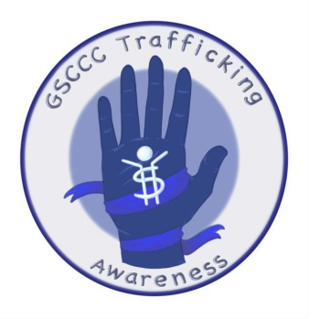

Human Trafficking Awareness
Council's Own Patch Program
Gold Award Project by Leah Cawley

The goal of the girl scouts Human Trafficking Awareness patch is to provide people with awareness for human trafficking cases in California. By learning about how and why human trafficking occurs, we can inspire each other to create awareness on this topic and create change in our community.

Once you complete the curriculum, please purchase your patch through DoubleKnot

Patch cost $5.00 includes shipping.

Human Trafficking Awareness
This patch provides girls with age-appropriate information about types of human trafficking. Girls are encouraged to ask questions and work together to complete the activities for the following subjects.
Juniors: Forced Begging
Cadette: Forced Begging
Seniors: Sexual Exploitation
Ambassadors: Sexual Exploitation
Requirements by Level
Level | Discover | Connect | Take Action
Juniors | 2 | 1 | 1
Cadette | 3 | 2 | 1
Senior | 3 | 2 | 1
Ambassador | 4 | 2 | 1

For this patch, it is recommended to have adult support and supervision throughout the activities. It is also strongly recommended that the different levels of girl scouts stick to their assigned topics. Each topic has been carefully selected and designed for the specific age group.
What is Human Trafficking?

Human trafficking is various illegal activities that include using tactics to control victims to perform acts or tasks against their will.

When Completing This Patch:
It is recommended to work in a group setting with an adult present to answer any questions or concerns. And keep in mind that all activities are age appropriate for each level, but still contains sensitive material.

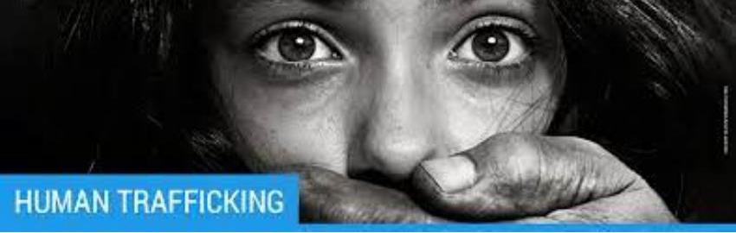
JUNIORS / CADETTES: FORCED BEGGING


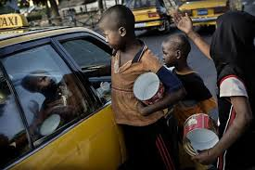 | 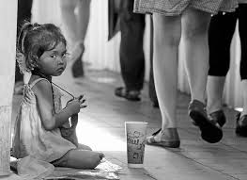
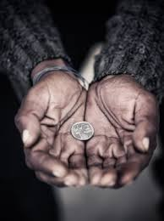 | 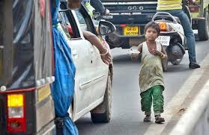

What is Forced Begging
Forced begging, also known as child labor trafficking, is one of the most seen forms of human trafficking. In fact, many people walk by it every day without noticing what they are walking by. Forced begging, while more common in foreign countries, is still common in the United States.
Forced begging becomes human trafficking when force, fraud, and coercion (practice of using threats or force to control someone) are involved. This is when a child predator, or a person that specifically targets kids, lures their victim into a forced begging scam using false promises and force to keep them there. For this reason, adults, kids, and families that come from a poorer economic situation are more at risk of becoming victims. For example, in foreign countries, a kid might go out looking for work to support their family and find someone that promises a lot of money for little work. Then they get stuck being forced to beg for money, and if they try to leave or get help they are threatened, and even hurt.
Most of the time, children that are forced to beg are given a quota, amount of money that they are supposed to collect each day, and if this amount isn't met, they are often punished by their abusers.
As stated above, forced begging is the most visible form of human trafficking, but also very easy to be ignored by passers by. However, if you ever come across a forced begging situation, it is important to let the authorities handle the situation so that you or someone else doesn't get hurt.

DISCOVER ACTIVITIES

Activity #1 — Color by Number (Juniors Only)
Colors: #1 = Red, #2 = Orange, #9 = Grey, #3 = Yellow, #10 = Brown, #5 = Blue, #6 = Purple, #7 = Pink
If you ever find your self in a dangerous situation, it is always important to go to a trusted adult. Many kids that are trafficked around the world have a hard time coming forward about being forced to beg on the sides of streets because they are embarrassed or afraid, and often keep that information to their selves. However, by talking to a trusted adult such as a police officer, you will not receive any judgement from anyone. The only thing you will get is help and support from the people around you.
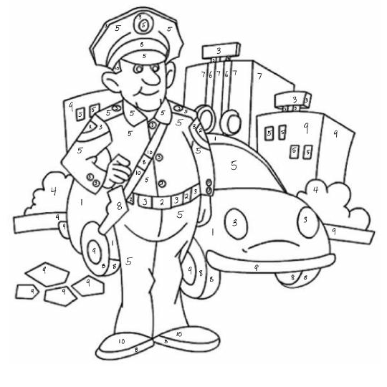
Activity #1 — Cause and Effect (Cadettes Only)
In this activity, work in small groups to read the paragraph, and complete the activity below.
There can be many different reasons that a child is forced into a forced begging situation. However, throughout multiple studies, it has become clear that the main root cause of forced begging boils down to poverty. The basic fact that many families worldwide have too little money to provide for their families, leads to the decision for parents to send their children out to the streets to beg. This can especially be true in popular tourist areas. In addition to poverty, another common root cause for forced begging can include threats of violence to the child, or the child's family, however this normally occurs to keep the child in a cycle of forced begging instead of the initial push to such a life.
Now that you understand how poverty can make a child more vulnerable to forced begging, the next thing to understand is how traffickers are then provided with opportunity to force a child into forced begging. Traffickers tend to prey on children in areas of poverty because they know that they will be easy to put into this forced begging cycle without being stopped by authorities. This targeting of children is highly effective, and another reason children are pushed into forced begging situations.
Now you may be asking, 'what happens to these children once they are inside of the forced begging trafficking rings'? Well, to understand that you have to look at the conditions of which these children are forced to beg. Often, the children have to face daily threats and abuse from the people who are trafficking them; leading to extreme mental damage. In addition, it is not uncommon for traffickers to hurt the child beggar so that they receive more sympathy on the streets and bring in three times the revenue. Therefore physical harm can be addd to the list.
Finally, children are often forced to work long, hard hours begging on the street for little to no money, little food, and limited to no access to education. Without access to an education or even proper nutrition, the childhood of these children is ripped away from them. Imagine not being allowed to play tag with your friends during recess, or not being able to come home every night to your parents/guardians and a nice warm bed to sleep in?
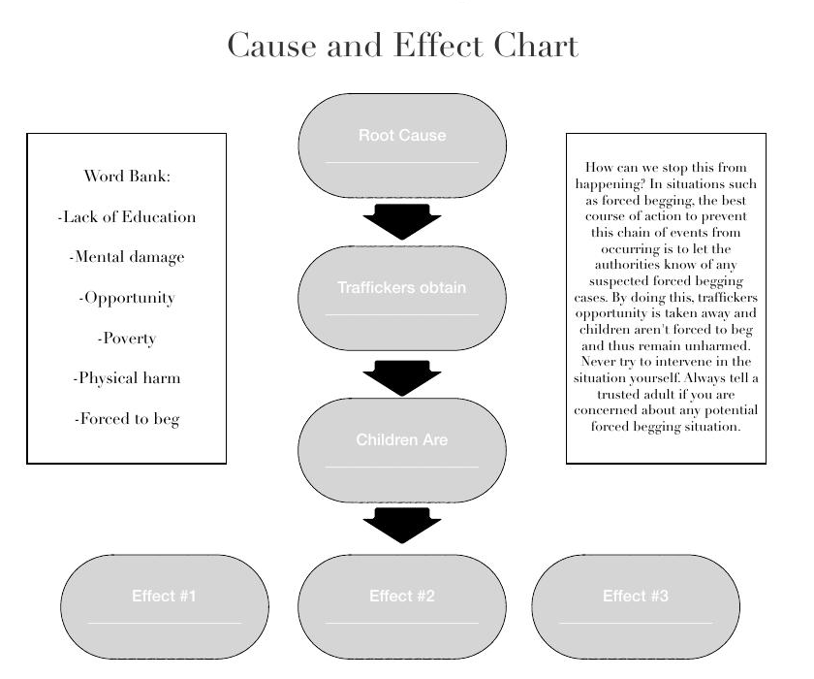
Word Bank: Lack of Education, Mental damage, Opportunity, Poverty, Physical harm, Forced to beg
How can we stop this from happening? In situations such as forced begging, the best course of action to prevent this chain of events from occurring is to let the authorities know of any suspected forced begging cases. By doing this, traffickers opportunity is taken away and children aren't forced to beg and thus remain unharmed. Never try to intervene in the situation yourself. Always tell a trusted adult if you are concerned about any potential forced begging situation.

Activity #2 — Video
Visit: https://youtu.be/mny_P49CRC4 and watch the video.
OR
Visit YouTube and watch the video 'What is Forced Begging' created by IOM X and watch the video.
After watching the video, complete the crossword puzzle below
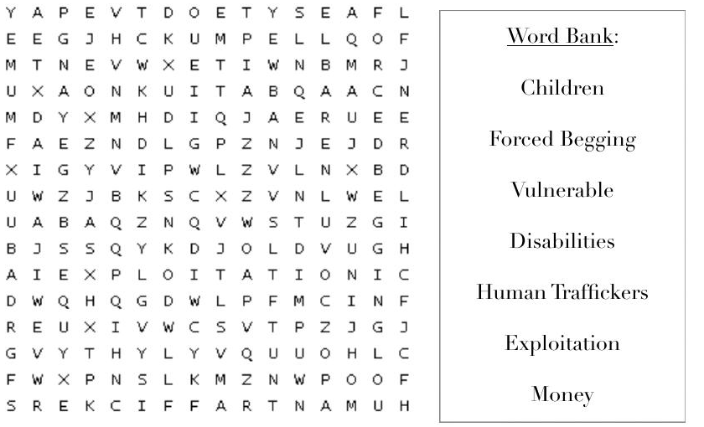
Activity #3 — Example Situations
Either as one big group, or in smaller groups, work together to analyze the situations below, and determine if the situations described are example of forced begging. If you have any questions or are not sure, make sure to ask an adult to help you. Answers are on the following page.
- Situation 1) You and your family are visiting a foreign country and decide to take a trip to the city. While you are there, you notice that there are a lot of kids sitting in the streets asking people walking by for money. You don't think much of it and walk away, but when you come back a few hours later, you see an adult walk up to each kid taking the money that they have collected throughout the day. You also notice that the kids seem to be scared of this person, as if they are afraid of being hurt. Is this an example of forced begging?
- Situation 2) You are walking around your town with your friends and family to visit a carnival to support your local schools. As you play games and have a good time, you notice that are are some booths where you can buy things like drawings from the local elementary school, or simple crafts made by the local middle school kids. You find a pretty bracelet and decide that you want to buy it, but when you go to the person running the booth, you notice that they are about your age, and seem to be running the booth with one other kid and no adults. As you look around, you see the adults are slowly walking through the booths to make sure there are no shoplifters. Is this an example of forced begging?
- Situation 3) As you are walking through downtown in your local community, you see a little girl in a wheel chair with one leg. You want to help her so you put some spare change into an empty coffee cup next to her wheelchair. As you turn to leave, you hear a commotion, and when you turn around you see that someone is scolding her for having collected very little money throughout the day. The stranger warns that if she doesn't meet her quota by the end of the day, she will not get any food for the next day. Is this an example of forced begging?
Answers
Situation 1) Yes. Forced begging is a very common type of human trafficking, and is easy to hide in plain sight. It is also very common to find in forgiven countries such as Africa; especially is big cities and tourist areas. Often times, the kids that are forced to beg are also given a quota to meet at the end of the day, and can be mistreated if a certain amount is not met. However, if you ever come across this in your travels, it is important to know never to give them any change. Most likely, they will never get to keep the money and it will go toward the people causing this issue. The best thing to do is to report your suspicions, and leave it to the professionals.
Situation 2) No. While forced begging can still occur in your community, it is extremely unlikely to happen at a school event. The kids working the booth are most likely volunteering to help their school increase funding, and the adults are simply letting the kids lead their own booths to build leadership skills. However, if you ever have any concerns about a potential forced begging situation occurring in your town, get a second opinion from a trusted adult.
Situation 3) Yes. Human trafficking, while most common in forgiven countries, is still likely to occur in our local communities. In this example, the traffickers exploited a little girl with a disability. Anyone with a visible disability is 33% more likely to become a victim. In addition, the example showed a person being punished for not having collected enough money. This scare tactic is often used to incite more fear and control over forced begging victims. If you ever come across this in your local community, it is important to immediately go to a trusted adult, and then to the authorities so that they can handle the situation. Never try to get in the middle of this situation, as trying to help without training can often make the problem worse.

Activity #4 — Crossword Puzzle
In this activity, use the following information to complete the crossword puzzle.
There are many misconceptions about forced begging. For example, California is the #1 state for human trafficking cases, and Sacramento is the #6 city for human trafficking. When many people think of human trafficking victims, they think of adults. However, what many people don't know is that 20% of all human trafficking victims are children. In the case of forced begging, 168 million children are forced to beg. In addition, 14% of trafficking cases are forced labor cases. And the worst part is that forced begging is the most visible form of human trafficking, but because of the lack of awareness on this topic, many people don't realize that by giving change to kids on the street they are actually adding to the forced begging crisis. While not everyone begging on the streets is necessarily a forced begging victim, the ones that are collect 30-40 thousand dollars per year. This makes forced begging a very lucrative, or a big money maker, and is relatively the least risky of all the human trafficking forms. One strategy that human traffickers use to collect more money from people walking on the street is by forcing kids with visible disabilities to beg. In fact, children with visible handicaps bring in three times the revenue compared to a child with no visible disabilities. This makes them more likely to be targeted. Children from foster care, abused children, immigrants, and run-aways are also at a higher risk of being trafficked.

Across:
2. The #1 State for human trafficking
4. Children with _______ bring in 3x the revenue
5. Most visible form of human trafficking
6. Human trafficking is very _______, bringing in 30-40 thousand dollars per year
Down:
1. #6 city for human trafficking
3. 20% of human trafficking victims are _______


Answers:
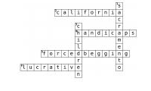
Activity #5 — Common Myths True/False
With human trafficking, there comes a lot of common myths. Read through the common myths listed below, and determine with a group if they are true or false.
- Human trafficking can only occur in foreign countries.
- Only foreign born and poor individuals are victims of human trafficking.
- Human trafficking victims will attempt to seek help when in public and always want help getting out.
- You need proof to report child trafficking.
- Traffickers target victims they don't know.
Answers
#1) False, human trafficking is a worldwide issue and occurs in every country including the United States.
#2) False, victims of human trafficking can be any age, race, gender, or nationality and come from many different social classes. However, some groups may be at a higher risk than others.
#3) False, many traffickers use fear in order to keep their victims isolated from the people around them, and to prevent them from reporting the trafficking. For this reason, many people are too afraid to report their trafficking situation.
#4) False, you do not need proof to make a report, just reasonable suspicion. If you ever suspect human trafficking, you should always report it and let the authorities determine if human trafficking is occurring, and how to handle the situation.
#5) False, while some victims are targeted by people they don't know, many people are trafficked by people that they know.

CONNECT ACTIVITIES

Activity #1 — Human Trafficking Awareness Companies
For this activity, work in small groups with your troop.
In your groups, work together to research different companies that support human trafficking awareness and pick a product from that company. Once your groups has chosen a product, make a poster or presentation explaining how it will help to raise awareness for human trafficking.
Follow the example below:
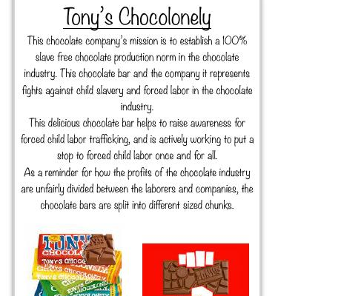
Activity #2 — Community Investigation
Where does human trafficking occur the most in your community?
Think back to a time when you were walking around in your community and noticed someone begging on the streets. While this may not necessarily be human trafficking, there is really no way to tell. Wether the beggar is an adult or a kid, they can still be victims of human trafficking.
Either with a small group or with one big group, look at a map of your local community and discuss where you think forced begging is most likely to occur in your community; or where you think you might have seen an example of forced begging. Label these places on the map.
Do you notice any trends in the places that you labeled? Places of poverty? Downtown area? Near a homeless shelter?
Infer with your group why these places may be more susceptible to having more forced begging victims?
Are there any places inside or out of the U.S. that could be home to a lot of human trafficking victims based on what your group has discussed so far?
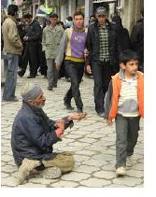 | 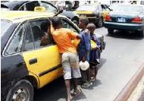
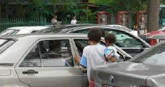 | 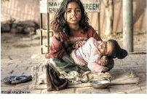

Activity #3 — Local Organizations Research
Are there any organizations in your community helping raise awareness?
As a troop, work together to find an organization located in your area that is doing their part to raise awareness for human trafficking. This organization could be anything from the local police, to an outpost for human trafficking victims, and could even include a nonprofit organization based in your community.
Once you have selected an organization, take a trip down to where they are located in your area and ask how they are raising awareness for forced begging, and how you can get involved in supporting the movement.
What did you learn from this trip that will help you to complete the rest of this patch?
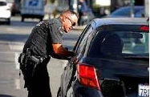 | 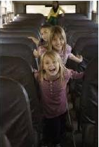 | 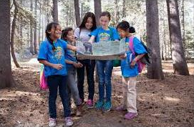

TAKE ACTION ACTIVITIES

Activity #1 — DIY Blue Ribbon
One of the key symbols to represent human trafficking awareness is the blue ribbon. For this activity, make blue ribbons and hand them out to friends and family at school, fundraisers, and other events. Make sure to explain what the ribbon stands for and what you learned about forced begging.
Instructions:
- Cut a small piece of blue ribbon (about 3 inches long) — if you want to add extra detail, cut the ends at a diagonal angle to add points at each end of the ribbon
- Fold the pieces of ribbon so that the right strand is over the left
- Make the iconic ribbon shape as shown in the photo and pinch the strands together
- Stick the pieces of ribbon together using one of the following: Clothing pin, Hot glue, Elmers Glue, Glue Dots, Tape (double sided recommended)
Activity #2 — Poster
In this activity, work with your troop to make one big poster combining everything that you have learned thus far. Once the poster is done, hang it up somewhere in your community where people will be able to see it, such as your school.
Make sure that the poster completes the required criteria:
- The poster has a creative title related to forced begging
- The poster is written by hand
- Add lots of color to make the poster more fun and eye catching
- Add decorations such as pictures (hand drawn or printed)
- Combine everything you have learned so far to create an educational poster
- Work as a group. Don't leave anybody out of this project
- Have Fun!
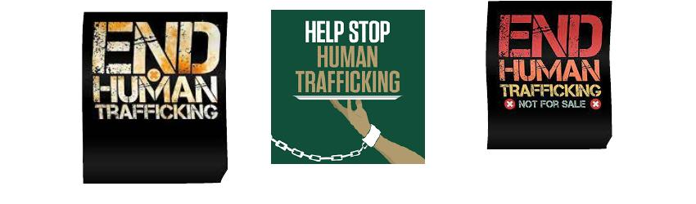

SENIORS / AMBASSADORS: SEXUAL EXPLOITATION


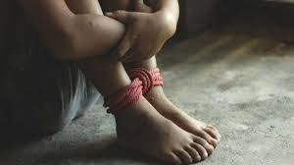 | 
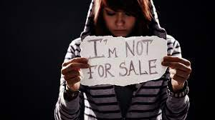 | 
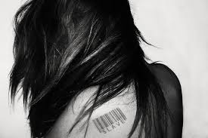 | 

What is Sexual Exploitation?
Sexual exploitation can take many forms, and not every situation involves force (at least at first). People usually exchange sex for money, food, clothes, or protection for themselves or their family. In addition, there are many cases where victims are forced to recruit other victims, including children.
Usually, sex traffickers work either independently or with small groups called pimp circles, gangs, or brothels. In some cases, when the victim does what they are told they are given a sense of control over their situation, even though the pimp almost always has complete control over the victim.
The definition for sexual exploitation is individuals who perform commercial sex through the use of force, fraud, or coercion. It is important to remember that minors under 18 are considered victims regardless of force, fraud, or coercion because they are below the legal limit to consent to sex.
In 2019, National Center for Missing and Exploited Children (NCMEC) estimated that 1 in 6 endangered runaways were likely sex trafficking victims. In cases where victims feel trapped and isolated from the people around them, the trauma they suffer from can be so great that many victims don't reach out for help. According to a survey done in Las Vegas, the races most at risk for include:
African Americans 63%, Caucasian 20%, Hispanic 6%, Asian 7%, Other 2%
The signs of this kind of trafficking include (but are not limited to): Disconnected from loved ones; Sudden change in behavior (disoriented, confused, timid, fearful, or submissive); Constantly in the company of someone in control; Showing signs of lack of food, water or medical care
If you or someone you know are being trafficked, or a friend is showing signs of being trafficked, call the Human Trafficking Hotline at 1(888)373-7888 or text “Help” or “INFO” to 233-733 (BeFree)

DISCOVER ACTIVITIES

Activity #1 — Video
For this activity, go to YouTube and search for the channel Fight Child Abuse. Look through some of their videos and watch 3 that you think are related to sexual exploitation. The recommended videos to watch include:
Teenagers and Sexual Abuse; Grooming & Sexual Abuse; Online Sexual Abuse Can Happen; Friends Can Help Stop Sexual Abuse
After watching your three videos with your troop, discuss: Common themes? What did you learn? What stood out to you the most? Would you show this to other kids in your community to help raise awareness? If you or someone you know is being sexual abused, what should you do to handle the situation?

Activity #2 — Common Myths
In this activity, read the following common myths about sexual exploitation and discuss with your troop or with your small group if you think the myth is true or false. After discussing all of the myths, read the answers on the next page.
- Only undocumented foreign nationals get trafficked in the United States.
- Human trafficking only happens in illegal or underground industries
- Only women and girls can be victims and survivors of sex trafficking
- People being trafficked are physically unable to leave their situations as a result of being locked in a room or held against their will.
- Traffickers target victims they don't know.
- People in active trafficking situations always want help getting out.
- Individuals must be forced or coerced into commercial sex acts to be victims of human trafficking

Answers
1. False: Even people born or naturalized in the United States with legal citizenship are at risk of being sexually exploited. However, having an illegal citizenship does increase vulnerability of the person.
2. False: Human trafficking cases have been reported to occur in certain industries such as restaurants, construction, factories, etc.
3. False: Some studies have suggested that 71% of human trafficking cases are women while only 29% of cases are men. However, many speculate that trafficking victims percentage in males is higher due to the fact that male victims are less likely to be identified
4. True and False: In some trafficking cases, there are victims that are physically unable to leave. However, some people stay in their situations for a variety of different complicated reasons. Such include staying out of fear, basic necessities to survive on their own, or the victim has been heavily manipulated.
5. False: Many victims have been targeted by romantic partners, teachers and family members.
6. False: While every trafficking situation is different, there can be many factors that prevent people from seeking help such as isolation, guilt, or manipulation.
7. False: According to U.S. law, any minor that is under that age of 18 who performs a commercial sex act is considered a trafficking victim regardless of other factors.

Activity #3 — Word Search
In this activity, read this Sexual Exploitation And Abuse PDF with your troop. The packet contains important information to help you get further perspective on the issue of sexual exploitation among adults and children. After having read the article, complete the crossword puzzle below.


Across:
3. WHO staff must work and behave in a manner that _____ the rights of the people.
5. _______ is committed to protect vulnerable populations.
6. Sexual Exploitation and Abuse (SEA) represents a fundamental ______ of protection
7. You can make a _______ report if you are supporting a victim of sexual exploitation and abuse
Down:
1. SEA stands for _________ _________ and Abuse.
2. If anyone has concerns about a possible sexual abuse case, they have the duty to ______ the issue.
4. Sexual exploitation/abuse occurs when a position of power is used for ______ proposes


Activity #4 — Example Situations
In this activity, read the following example situations below. As a group, decide wether or not the situation is an example of human trafficking. If you and your group decide that the situation is an example of human trafficking, decide what your actions should be in the situation.
Example Situations:
- You and your best friend are walking through the mall trying to find a dress for the upcoming school dance. When your friend comes out of the dressing room in a possible dress, a man approaches you both claiming to work for a modeling agency. He hands his card to your friend and tells her to give him a call. However, upon looking at the card you notice that it doesn't look real, and when you google the name of the modeling agency at the bottom of the card, you don't get any results. Your friend won't listen to you when you tell her that you think it is a scam and calls the guy the next day about the modeling job. One week later, you notice that your friend has dramatically changed her wardrobe to be very mature for her age, she is constantly coming late to school, and is also afraid to leave after school. Is this an example of human trafficking?
- A woman from a small town moves to a big city, and realizes that she doesn't know her way around as well as she thought. While she was walking through the streets she bumps into a handsome man and asks for some help. He helps her find her way around the city, and they decide to go out for coffee. After some time, they decide to start dating, and things are going great! After some time however, the boyfriend starts to ask favors of the girl like sleeping with his 'friend' and collecting some money that he is owed after. Confused, but convinced that they are in love, the girl agrees, and her boyfriend gives her jewelry and fancy clothes as a 'thank-you'. As time goes on, the favors get bigger and bigger and the girl can't seem to find a way out of the situation. Is this an example of human trafficking?
- A middle school teacher named Kiana cares deeply about her students and works hard to make sure that they are happy both inside and outside of class. Recently, a girl in her class has started acting out a lot more, even though she is usually one of Kiana's best students. Kiana decides to pull the child aside and asked her what was wrong. Kiana's student responds that she is pregnant. Kiana was shocked at the answer and asked which other student in the school is the father, hoping to set up a meeting between the two in order to figure out what to do. The student responded that this was not necessary because the father was not actually her age, and was in fact one of the other teacher on campus and that they were in love and going to get married when she was old enough. Is this an example of human trafficking?

Answers:
1. Yes, this situation is an example of human trafficking. Many victims get pulled into a sexual abuse ring by mistake, and in this case, the girl thought she was given the chance to be a model. Often in these situations, the victim is pulled into a human trafficking ring, and threaten that if they leave or tell anyone, they are putting themselves or a loved one in danger of being hurt or killed. Sometimes they are even threaded with video tapes and pictures in order to stay trapped in the sexual abuse cycle.
2. Yes, this is an example of human trafficking. In this situation, the girl was tricked into thinking that they were in a serious relationship. The 'boyfriend' in this scenario used manipulation and coercion tactics to convince the girl to sleep with his paying customers. These situations can be really tricky to get out of because the victim is often convinced that they are in love and have difficulty leaving the people they are supposedly in a relationship with.
3. No, this is not an example of human trafficking, but this is an example of sexual abuse. The difference between this case and the other cases is that the crime committed was statutory rape. The difference in rape from the other two example situations is that the victims in the other ages were forced or coerced to have sexual relations with someone that they didn't want to be with in exchange for money. In the third situation, while the middle school student was not necessarily forced to have sex, she is below the legal age to consent to such activities with an other man, making it statutory rape. However, child predators often try to convince their victims that they are in a serious relationship in order to avoid the child telling people about their 'relationship' by saying that “people won't understand our love”, which adds an extra layer of manipulation on the victim.
Discuss, what would you do in this situation? Put yourself in the shoes of the people hearing about these situations and discuss what you would do in the best interest of the victim.

Activity #5 — Special Victims Unit
*This activity requires a Hulu subscription
In this activity, you and your troop will watch an episode from Law and Order Special Victims Unit. Pick one of the following episodes below to watch. Some of the episodes can be graphic but they provide an insight into how law enforcement officers work a Human Trafficking case.
Episodes to watch (choose 1): Season 12 Episode 4: Merchandise; Season 12 Episode 15: Flight; Season 14 Episode 4: Acceptable Loss; Season 16 Episode 15: Undercover Mother
Important to note that some episodes may be too graphic for sensitive viewers.

CONNECT ACTIVITIES

Activity #1 — Court Cases
In this activity, visit U.S. Attorney Highlights 2021 Human Trafficking Cases to Bring Awareness During Human Trafficking Prevention Month, and read through a few of the court cases with your troop. After you have done this, pick one court case with your troop and fill out the questions below with information pertaining to your chosen trial.
- Who is the victim in this trial (name)? ____________
- Who is being prosecuted and what crime(s) have they committed? ____________
- What is the name of the case? ____________
- Who was involved in the investigation of this case? (Which law enforcement agencies and/or specific people investigating) ____________
- What do you think about the process of prosecuting a human trafficker. Do you like or dislike the process? Why? Do you think there are ways to improve the system? Discuss with your troop.

Activity #2 — Initiatives By Presidents
For this activity, follow the steps listed below:
Visit a few of the following websites and read about current and past presidents plans to combat human trafficking in the United States:
- President's Interagency Task Force to Monitor and Combat Trafficking in Persons
- George Bush - White House Archives - Human Trafficking - a New Form of Slavery
- Federal Government Efforts to Combat Human Trafficking
- Countering Trafficking in Persons
Make a list of some of the initiatives that you read about. Use the chart below you to help organize them.
Initiatives I Agree With | Initiatives I Feel Neutral About | Initiatives I Disagree with

Discuss: Are there any initiatives that you would like to see implemented? If so, work as a troop to write a letter to a government official (President, Congressman, Senator, etc.) explaining the initiative you would like implemented and why. Follow the format listed below:

Return address for the letter
Date letter was sent
The Honorable (chosen government official)
Ex. The Honorable Anna Eshoo
House of Representatives or Senate or Local officials
Ex. California Congresswoman 18th District
Dear chosen government official,
Paragraph #1: Introduce your troop and your purpose for writing.
Paragraph #2: Describe the initiative that you would like to see implemented. Go into detail why you would like to see this implemented.
Paragraph #3: Back up your opinion by describing who it would help and how it would help them.
Paragraph #4: Bring your letter to a close. Restate your purpose and request for actions. Thank the official for their time and considerations.
Sincerely,
Troop #
(Optional: add the names of the people in the troop)

Activity #3 — Where Sexual Exploitation Occurs
In this activity, work with your troop to research where sexual exploitation occurs the most. Use the world map below, and color in the hotspots for human trafficking. Use the color key to help you.
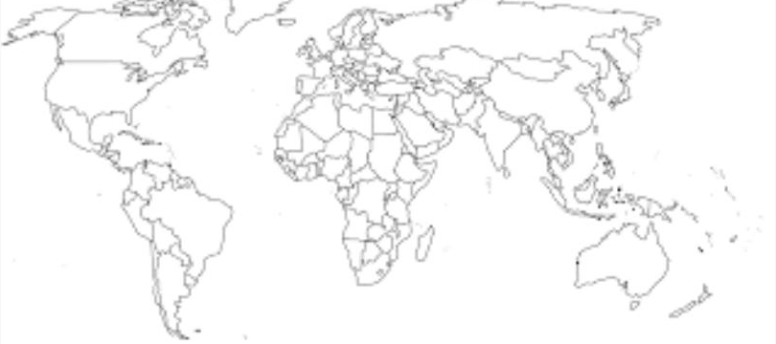

Color Key
Dark Red - 10 million+ cases per year
Orange - 7-10 million cases per year
Yellow - 3-7 million cases per year
Green - 1-3 million cases per year
Blue - Less than 1 million cases per year

TAKE ACTION ACTIVITIES

Activity #1 — Awareness Poster
In many human trafficking situations, the victim is hardly left alone by the abuser when going out in public. However, there are certain places where the victim is left to be by themselves, such as the bathroom.
Have you ever noticed that in some public bathrooms there are posters in the stalls? Sometimes they are advertisements for certain companies, but many times they are posters advocating for human trafficking victims protection. Posters such as these have helped many people find help out of their situation, get help, and get justice against their abusers in court.
Watch this YouTube Video - Bathroom Posters That Can Save Sex Trafficking Victims Lives for more information.
For this activity, work in small groups with your troop to make some posters advocating for human trafficking awareness and protections.
Include a number to text/call to receive help, common signs of human trafficking to identify in others, benefits of recovering help, etc. Some examples are shown below.
After your troop has finished the posters, hang them up in public areas or in bathrooms at school or a local restaurant with the permission of the establishment.
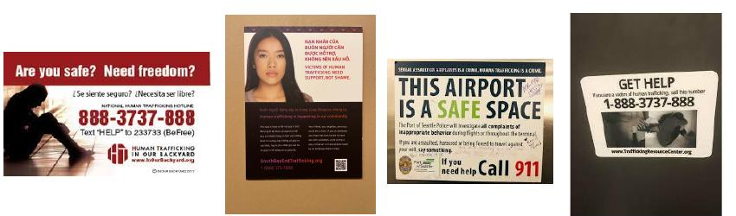

Activity #2 — Blue Ribbon
One of the key symbols to represent human trafficking awareness is the blue ribbon. For this activity, make blue ribbons and hand them out to friends and family at school, fundraisers, and other events. Make sure to explain when the ribbon stands for and what you learned about forced begging.
Instructions:
- Cut a small piece of blue ribbon (about 3 inches long) — if you want to add extra detail, cut the ends at a diagonal angle to add points at each end of the ribbon
- Fold the pieces of ribbon so that the right strand is over the left
- Make the iconic ribbon shape as shown in the photo and pinch the strands together
- Stick the pieces of ribbon together using one of the following: Clothing pin, Hot glue, Elmers Glue, Glue Dots, Tape (double sided recommended)

Activity #3 — Raise Awareness
In this activity, host another girl scout troop and help them to earn this patch based on the level that they are. Follow the following guide lines during the sessions:
- The program must be girl lead with adult supervision. Adults are allowed to be present, but are not allowed to be the main people leading this patch.
- Make sure to keep the girls you are teaching engaged. Additionally, find a job for everyone in your troop to do during the patch program, and try to divide the work evenly.
- For the craft portion of the patch (blue ribbon), make sure to have all of the proper materials available, and be familiar on how to complete the craft.
- Have fun! Don't make the patch activities a talking session, and include fun activities along the way.
