

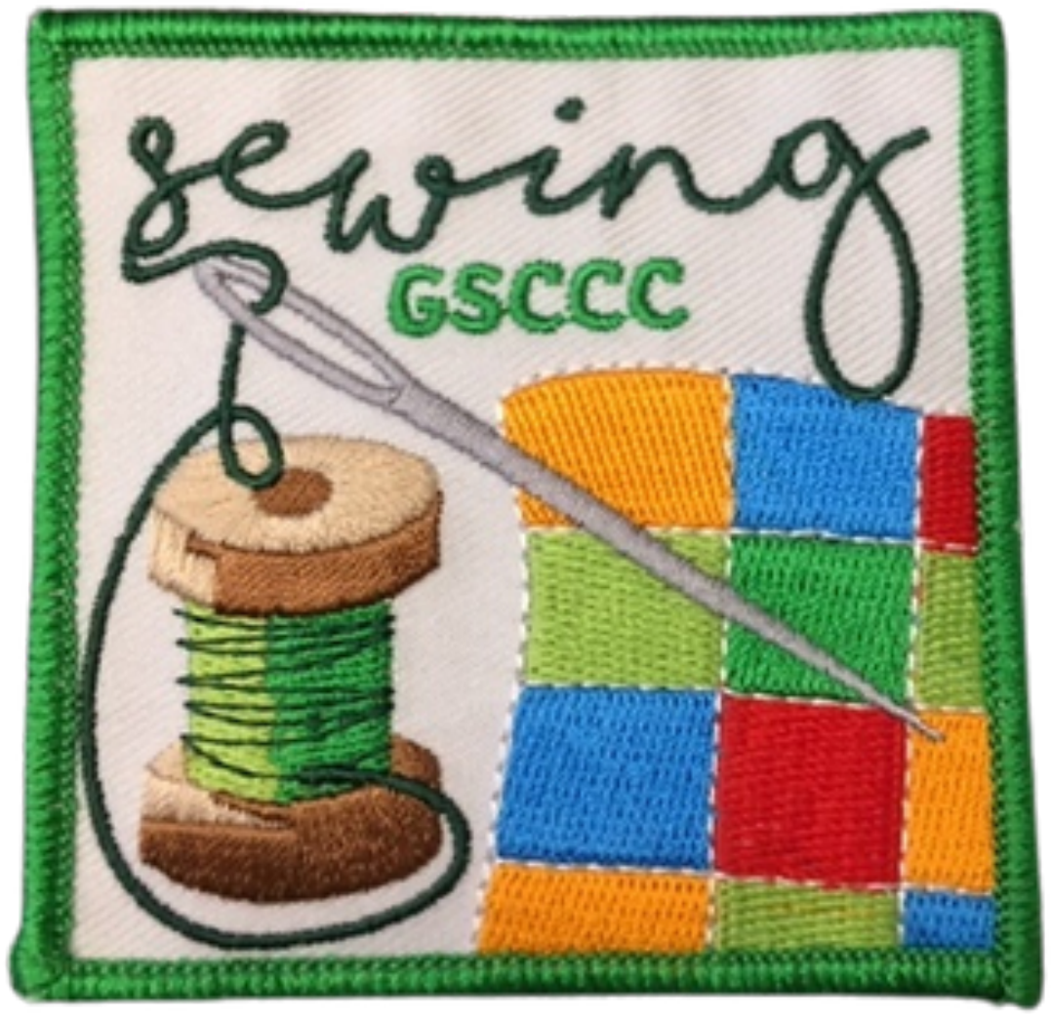

Girl Scouts Sewing
Council’s Own Patch Program

This patch program was designed by Troop 32140 from Monterey County.
Discover the fun and creativity of sewing while learning skills you can use for a lifetime! Explore sewing tools, practice basic hand stitches, learn how a sewing machine works, and put your new skills to work creating projects for yourself and others.

Once you complete the curriculum, please purchase your patch through DoubleKnot

Patch cost $5.00 includes shipping.

The first step to earn the Sewing Patch is to Watch this video.

GS Level Requirements
To complete this patch all levels should do requirements 1, 2, 3, 4, 5 and 6. We have included some additional sewing activities to do. Please choose one extra activity to practice your sewing skills.

Level | Required | Additional Requirement
Daisy | 1,2,3,4,5,6 | one extra sewing project
Brownie | 1,2,3,4,5,6 | one extra sewing project
Junior | 1,2,3,4,5,6 | one extra sewing project
Cadette | 1,2,3,4,5,6 | one extra sewing project
Senior | 1,2,3,4,5,6 | one extra sewing project
Ambassador | 1,2,3,4,5,6 | one extra sewing project

REQUIREMENTS LIST

- Make a Sewing Kit. https://www.youtube.com/watch?v=Dp1npG1nEpo
- Learn about Sewing supplies. (examples: rotary cutter, rulers, mat boards)
- Learn about the basics of how to use a Sewing Machine. (example: How to thread) *there are many videos you can find online*
- Learn Basic Running, Blanket, And Whip Hand Stitches. *there are many videos and information you can find online or ask an adult for help*
- Go To A Fabric Store Near You or watch virtual video.
- Make Something to Give Back to the Community or local charities.

EXAMPLES OF ADDITIONAL ACTIVITIES

- Finger Puppets
- Sew Your Badges on Your Vest.
- Make A Pencil Case
- Make an Eyeglass case
- Make a Button Collage
- Make a Felt Star Wand
- Make A Cat or Dog Toy
- Sew a Blanket for a Cat or Dog
- Make Hats For Charity
- Make Scarves for Charity
- Make Mittens for Charity
- Bean Bags
- Scrunchies
- Rag Dolls
- Pillow Case
- Dish Towel Apron
- Drawstring bag
- Car Trash Bag
- Pajama Pants
- T-Shirt Bag
- Needle book holder

INSTRUCTIONS FOR MASON JAR PIN CUSHION SEWING KIT

You will need:
- Mason Jar
- Needles
- Thread
- Fabric (5 inch circle)
- Felt (2 inch circle)
- Small amount of stuffing
Instructions:
- Cut a 5 inch circle from your fabric.
- Make a running stitch all the way around the circle about ¼ of an inch from the edge.
- Pull the thread gently to make the fabric go around the metal disc of the mason jar lid. Do not pull tightly yet.
- Stuff a small amount of stuffing between the metal disc lid and fabric. This is where you will put your sewing pins. Once the stuffing is in place pull the thread tightly and make a knot.
- Glue the felt circle to the inside of the jar lid.
- Place on a mason jar, if the fabric disc does not stay in the metal ring you can glue these together.
- Place all your sewing supplies in your jar.
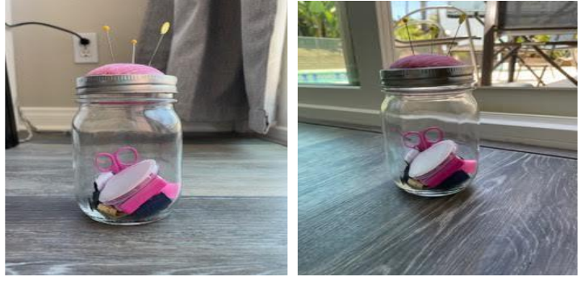
Examples

INSTRUCTIONS FOR SCRUNCHIES

Needed:
- Sewing Machine
- Fabric 18 in. by 3 1/2 in.
- Elastic (7 inches long)
- A needle and thread
Instructions:
- Cut an 18 in. by 3 1/2 in. piece of fabric (your choice).
- Fold in half with wrong side fabric out and sew along the long edge leaving the short edges open for elastic.
- Turn fabric to right side of fabric on the outside. You will have a tube.
- Thread elastic through the tube and stitch elastic ends together.
- Sew the fabric together and you have made a scrunchie.
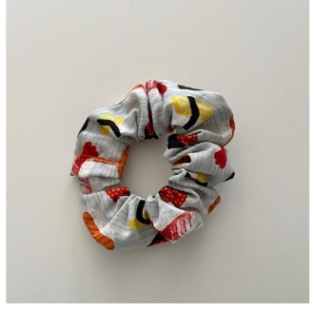

INSTRUCTIONS FOR BEAN BAGS

- Cut a 3 in. by 3 in. piece of fabric (your choice)
- Flip your bean bag inside out so the seam is inside your bag and sew three sides of the bean bag using your sewing machine or sew by hand.
- Flip your bean bag right side out so your stitches are on the inside of the bean bag and fill your bean bag with pinto beans, rice, or other dried beans you have on hand.
- Sew the side you didn’t sew closed and play!!!!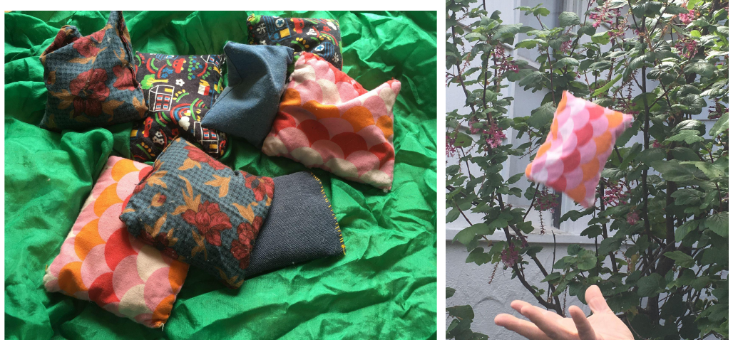

INSTRUCTIONS FOR FINGER PUPPETS

How to make a butterfly puppet

Needed:
- 4 inch by 4 inch felt fabric.
- Butterfly pattern (see pictures for shape)
- Scissors.
- Needle and thread.
- Hot glue gun. (Optional)
- (optional) Extra fabric and/or sequins, beads, jewels for decoration
Instructions:
- Make a butterfly pattern and cut out two pieces of felt using the pattern.
- Place the two pieces of felt on top of each other.
- Starting at the upper wing using a blanket stitch or running stitch, start sewing the two pieces of felt together a quarter inch from the edge of the fabric along the upper wing down the bottom.
- When you get to the bottom center of the butterfly start sewing straight up the middle the width of your finger to the top of the butterfly.
- Repeat on the other wing.
- (Optional) Cut out decorative shapes from felt and use a hot glue gun to glue them on your butterfly.
- Now you have made a butterfly puppet!
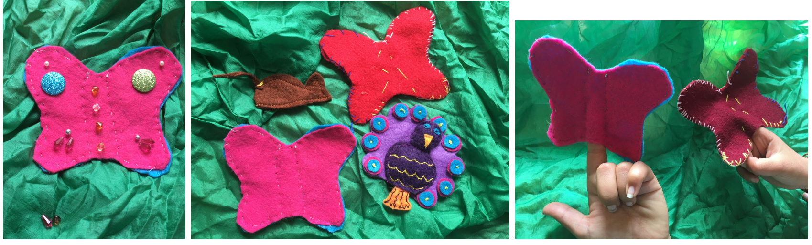
Ideas

SAMPLE GIRL SCOUT MEETING – DAISY, BROWNIE, JUNIOR

***This sample is for a 2 hour meeting and can be done with hand sewing only***
- Start meeting with flag ceremony
  - Girl Scout promise and Law
- Sewing supplies – Place these items on a tray:
  - Sewing needles
  - Thread
  - Scissors
  - Thimble
  - Needle threader
  - Embroidery floss
  - Pins
  - Ruler
  - Show girls all items on the tray and explain the use for each one. Then cover the tray and take an item away. Show girls the tray again and have them guess which item is missing.
- Show the girls how to use a sewing machine (If you do not have a machine we have included a video of sewing machine basics)
- Make a mason jar sewing kit pin cushion (instructions included above)
- If girls cannot visit a local fabric store, you can watch the video of our local shop
- Make a needle book from felt – have the girls practice hand stitching
  - They can sew on buttons, practice different hand stitches and design a cover they love.
- Make a felt cat toy
  - You can make any shape, fill the inside with a small amount of stuffing and cat nip, and then donate to your local shelter.
- End of meeting

