

Girl Scouts Go Green
Making a Difference through Conservation
Online Patch Program

Girl Scouts Go Green
Council’s Own Patch Program

One of the provisions of the Girl Scout Law is that Girl Scouts use resources wisely. This patch is all about building simple, everyday green habits at home — five easy steps, no research project required. Complete this program and you'll know some ways to make an impact, starting today!

Once you complete the curriculum, please purchase your patch through DoubleKnot

Patch cost $5.00 includes shipping.

Girl Scouts Go Green
One of the provisions of the Girl Scout Law is that Girl Scouts use resources wisely. What exactly does that mean? How can you, as a girl, make a difference through conservation of resources? Complete this program and you will know some ways to make an impact!
This patch focuses on small, everyday habits any Girl Scout can start right away at home. Looking for a deeper dive? Older Girl Scouts can explore the Girl Scouts Forever Green patch program, which digs into environmental issues and community action projects.
Steps
- Water
- Energy
- Resources
- Habitat
- The Three R's

Purpose
When I have earned this patch, I'll know how I can make small changes in my life and my household that will help us to “Go Green!”

STEP 1: WATER

1. Where does your water come from? Where does it go? Contact your local water district to find out where your water comes from. You may be surprised to learn that your water comes from hundreds of miles away. Or you may find out that it comes from a well, lake or other water source in your region. What is the journey like from its source to your tap? And what about when it goes down the drain? Where does it end up once it goes down the drain? Your water or sanitation district may even offer tours of their facilities. If you're lucky enough to be able to take one, round up some fellow Girl Scouts, so you can learn together! | 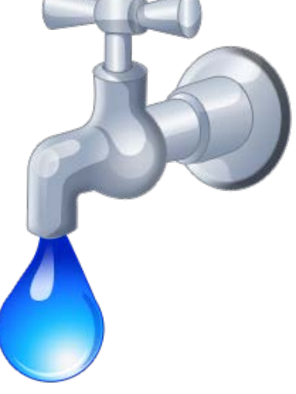

2. Identify the heaviest uses of water usage in your household, and with your family's help, devise and implement ways to cut back. These could include reducing sprinkler times (or turning sprinklers off completely), adjusting the schedule to run in the early morning when there will be less evaporation, adding a cover for your pool, taking shorter showers, and only running full loads of clothes or dishes. Your local water district may even have devices, such as faucet aerators, shower heads, and shower timers that they can offer you for free to help you with your quest.
3. Go on a leak hunt. With an adult, check the faucets, toilets, and hoses around your home for drips or leaks. Fix what you can, or ask an adult to help. Even a small leak can waste gallons of water every day!

STEP 2: ENERGY

1. Bright Idea: Count how many light bulbs are used in one room of your home. With an adult's help, swap one bulb for an LED, and compare the brightness and heat given off by the old bulb versus the new one. | 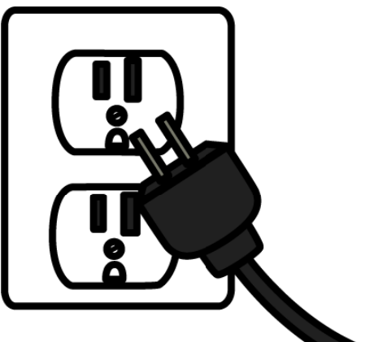

2. Look around your house – are there any instances where energy can be saved? (Examples might include devices that are infrequently used, but could be unplugged between use; washers and dryers running on loads that are less than full; lights left on; and more!) Make a list of potential energy “vampires” and discuss with your family. Create a plan for saving energy in the house, based on your list.
3. Energy is also used, in the form of fossil fuels, in your vehicle. Work with your family to determine ways to cut down on driving. Maybe you can carpool with another family to school one day a week, or combine trips to reduce back-and-forth, or even bike or walk instead of driving. Every little bit helps!

STEP 3: RESOURCES

1. Learn about natural resources, such as: fossil fuels, fresh water, wood and other plants, and metal ores. Additionally, renewable energy sources such as wind, solar, geothermal, and hydro energy are natural resources. Which of these resources are renewable, and which are not? Create a visual aide, such as a poster, photo collage, or flash cards, and share your findings. | 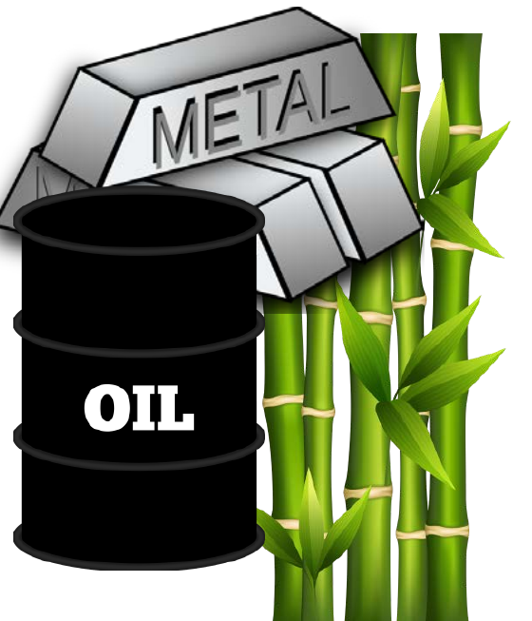

2. Survey a room in your home. What natural resources are being used? Which are renewable, and which are not? Create a tally chart of your results.
3. Identify ways that your household uses nonrenewable natural resources. Determine how these could be replaced with renewable resources, or at least replaced with less resource-intensive items (for example, this could include single-use water bottles, plastic shopping bags, and more).

STEP 4: HABITAT

1. Grow a Pollinator Patch: With an adult's help, plant a small pot or patch of California native, drought-tolerant flowers that attract bees, butterflies, or hummingbirds. Check on it once a week and keep track of which visitors you see. | 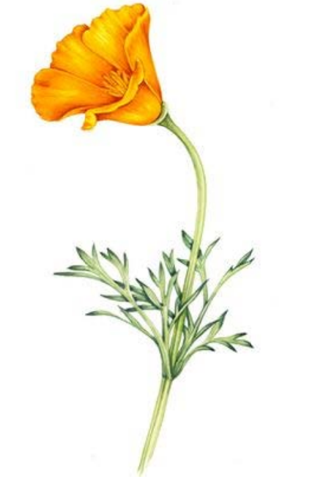

2. Build a Home for Wildlife: Create a simple habitat feature at home, such as a birdhouse, bee hotel, brush pile, or shallow water dish for birds and insects. Notice how small features like this can help wildlife thrive, even in a small yard, balcony, or patio.
3. Rethink Your Space: Look at the outdoor space at your home, school, or troop meeting spot. Is it mostly grass or hard surface? Does it include plants that give food or shelter to local wildlife? Identify one small change that could make that space more welcoming to birds, bees, or other backyard creatures.

STEP 5: THE THREE R'S

1. Recycle - Learn about the numbers printed on plastic items and what they mean. Which ones can be recycled in your community? Make a sign for your recycling container at home with your results (set one up if you don't have one already!), and encourage your family to recycle. | 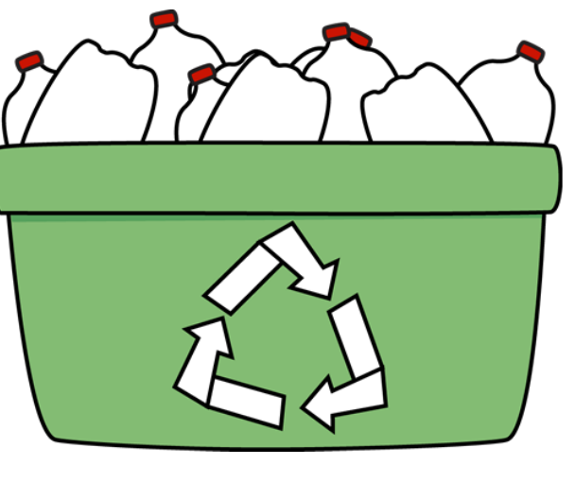

2. Reuse - Rescue an item from your trash stream and figure out how to reuse it. For example, an empty tissue box can be used to store plastic shopping bags (so they can be used to collect and dispose of trash!); an empty plastic tub from your margarine, yogurt, cottage cheese, etc. can be used to store small things, or to bring lunch items in. All kinds of materials can be used for arts and crafts. The possibilities are endless!
3. Reduce – Food scraps are one of the biggest sources of household trash, and they don't have to go to waste! With an adult's help, start a simple compost bin at home (even a small countertop bin works), or find a local green-waste or composting program you can use instead.
Want to go deeper into reducing waste? Check out the Reduce Waste section of the Girl Scouts Forever Green patch program!

Now that I've earned this patch, I can give service by:
- Educating others about the conservation of resources, and how easy it can be.
- Setting up a recycling program in my household, school, or community.
- Protecting native habitat and the organisms that depend upon it.

One habit I'm going to start this week is:

Ready to take your green habits further? Try the Preserving Our Resources – Girl Scouts Forever Green patch program!

