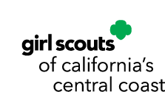

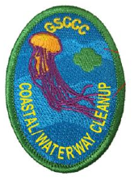

Coastal / Waterways Cleanup
Council’s Own Patch Program

Become a champion for cleaner, healthier beaches and waterways! Explore the plants and wildlife that depend on these habitats, discover how pollution and human activities affect them, and take action through cleanups, data collection and community education to help protect these important ecosystems.

Once you complete the curriculum, please purchase your patch through DoubleKnot

Patch cost $5.00 includes shipping.

To earn the Coastal & Waterway Cleanup Patch:
- Complete two (2) or more Discover program requirements
- Complete all Connect program requirements
- Complete two (2) or more Take Action requirements

DISCOVER

Learn About Local Beach or Inland Waterway Environments
- Find out what issues may be impacting the health of local beaches and waterways. What can be done to help alleviate these issues?
- Learn about the kind of care everyone visiting the beach and inland waterways should exercise in order to protect marine life and oceanfront or waterway habitats.
- What common plants and marine life inhabit the local coastline or waterways.
- What are the most common birds on local beaches or waterways? What impacts them the most?
- What is the most common marine animal or reptile living on local beaches or waterways? What impacts them the most?
- What is the most common plant on local beaches or waterways? What impacts them the most?

CONNECT

Become a Waterway Hero
- Choose Your Waterway
Select a local beach, creek, river, lake, lagoon, wetland, harbor, or other waterway that you want to help protect. Find out who manages or cares for the area and whether permission is needed before conducting a cleanup.
- Connect with a Waterway Expert
Meet or talk with someone who works to protect local beaches, waterways, wildlife, or habitats. This could be a park ranger, naturalist, marine biologist, environmental educator, watershed specialist, conservation volunteer, or another environmental professional. Ask about the biggest challenges facing local waterways and what Girl Scouts can do to help.
- Put Your Predictions to the Test
Remember the litter you predicted you would find during Discover? Now it's time to investigate! Conduct a cleanup and use the Coastal & Inland Waterway Tally Form to record what you collect. Compare your results with your predictions. What did you find the most of? What surprised you? Where do you think the litter came from?
- Make It a Cleanup Challenge
Complete four (4) cleanups over the next year at your selected beach or waterway. Invite family, friends, your troop, or members of your community to join you. Record your findings after each cleanup and submit your completed tally forms to GSCCC. Compare your results over time. Is the amount or type of litter changing? Are there patterns you notice?
- Experience Conservation in Action
Participate in a beach, waterway, wildlife, watershed, or environmental education program in your community. Look for connections between what you learn during the program and what you have observed during your own cleanups.
TAKE ACTION

Turn What You Learned Into Change
- Solve a Litter Problem
Look at the data from your cleanups and identify one item or type of litter that appears frequently. Where is it coming from? Brainstorm a solution that could prevent it from reaching the water in the first place. Put your idea into action!
- Teach Others to Protect Our Waterways
Create posters, signs, a presentation, display, social media campaign, video, or other educational project that teaches others about an issue affecting your local beach or waterway. Be sure to include something people can do to help.
- Grow Your Cleanup Crew
Organize or promote a beach or waterway cleanup and invite other Girl Scouts, families, friends, classmates, or community members to participate. Teach your volunteers why cleanups matter and show them how to collect useful data while they work.
- Partner for Change
Share your cleanup findings with a park, marina, harbor, school, business, environmental organization, or community group. Ask if there is something you can work on together to reduce litter or protect the habitat. You might suggest additional trash or recycling containers, fishing-line recycling stations, educational signs, refill stations, or another solution based on what you discovered.
- Speak Up for Your Waterway
Research a local issue affecting beaches or waterways and make your voice heard. Write a letter or email to a community leader or elected official, attend a public meeting, create a petition, or give a presentation explaining the issue and the change you would like to see.
- Challenge Single-Use Plastics
Investigate the disposable items you use at home, school, troop meetings, or events. Choose one or more that could be replaced with reusable alternatives and challenge others to join you. Track how much waste you prevent.
- Protect Waterway Wildlife
Choose a problem that affects local wildlife—such as fishing line, balloons, plastics, habitat disturbance, or feeding wildlife—and create a project that helps people understand how their choices can protect animals and their habitats.
- Share Your Results
Turn your cleanup data into a graph, infographic, display, presentation, or short video. Share what you found, how the results changed over time, and what your community can do to help keep local waterways clean

Coastal & Inland Waterway
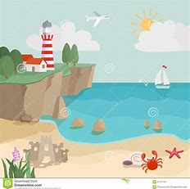
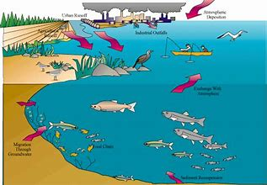
Tally Form

ITEMS | # OF ITEMS COLLECTED | COMMENTS
MOST COMMON
Cigarette Butts
Plastic Straws
Plastic Smaller than a Quarter
Plastic Larger than a Quarter
Styrofoam Smaller than a Quarter
Styrofoam larger than a Quarter
OTHER
Plastic Bottles
Plastic Bottle Caps
Plastic Shopping Bags
Balloons
Glass Bottles
Glass Fragments
Aluminum
Boat & Fishing Debris
Other

Coastal & Inland Waterway
Tally Form

ITEMS | # OF ITEMS COLLECTED | COMMENTS
MOST COMMON
Cigarette Butts
Plastic Straws
Plastic Smaller than a Quarter
Plastic Larger than a Quarter
Styrofoam Smaller than a Quarter
Styrofoam larger than a Quarter
OTHER
Plastic Bottles
Plastic Bottle Caps
Plastic Shopping Bags
Balloons
Glass Bottles
Glass Fragments
Aluminum
Boat & Fishing Debris
Other

