

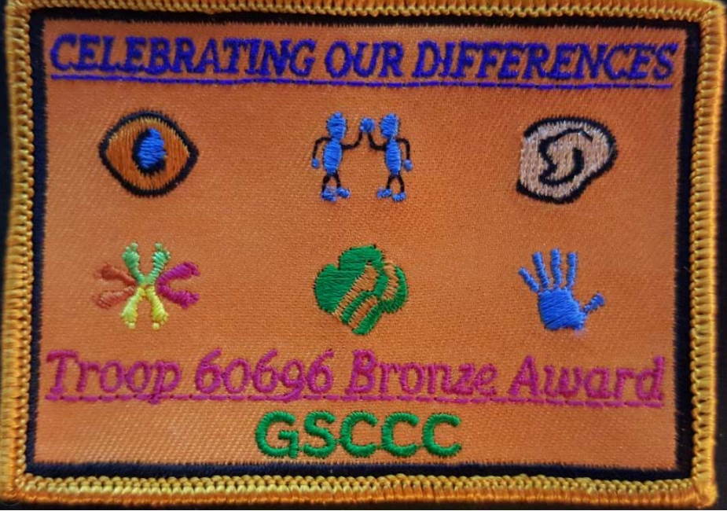

Celebrating Our Differences
Council’s Own Patch Program
Daisy / Brownie / Junior Levels

Discover how our differences make each of us unique! Learn about different types of disabilities, experience activities that build understanding and empathy, and explore ways to communicate, include, support and celebrate people of all abilities.

Once you complete the curriculum, please purchase your patch through DoubleKnot

Patch cost $4.00 includes shipping.

Introduction
Thank you for taking the time to experience and explore the Celebrating our Differences patch program with your girls! The purpose of Girl Scout Junior Troop 60696’s Bronze Award patch program is to heighten awareness, understanding and acceptance of people of all abilities.
This program blends patch programs developed by the Girl Scout Council of the Nation’s Capital, Girl Scouts San Diego, and Girl Scouts Mile Hi Council for Girl Scouts at the Daisy, Brownie, and Junior Levels.
To earn this patch each Girl Scout needs to accomplish each of the topics in upper case starting with the Beautiful Orange and ending with the Disability Awareness Quiz. Junior Troop 60696 has added information from their research on each topic. Please read over the information, share, and discuss. Girls can complete the activities individually or in a troop.

PLEASE START WITH THIS ACTIVITY FIRST

The Most Beautiful Orange
Materials: orange for each girl, stickers, markers, towel or cloth, bowl, plate, (1) prepeeled orange
Give each girl an orange and ask them to decorate the skin with the supplies you provide; tell them you’ll be having a contest to choose the most beautiful orange. When the oranges are decorated, collect them in a bowl and walk away so that you can “judge” them. Return with the pre-peeled orange under a cloth and announce while revealing it that you’ve chosen the most beautiful orange. Ask the girls, “Whose orange is on the plate?”
Discussion: What matters most is not on the outside, but the inside, where we’re all more alike than different. How did you react to this activity? What did you think was going to happen? What did you learn?

LEARNING DISABILITY

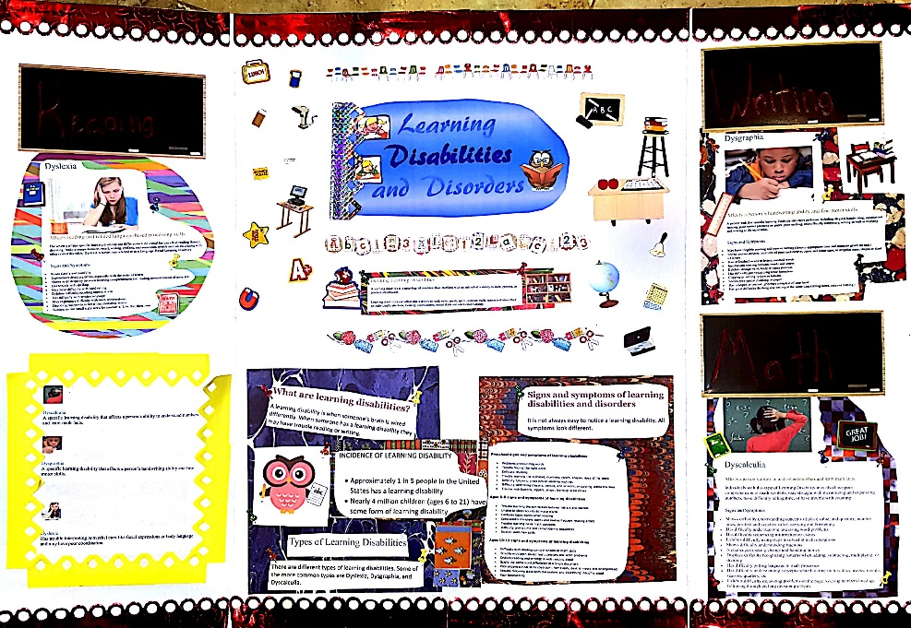

What is a Learning Disability?
A learning disability is a neurological condition that interferes with an individual’s ability to store, process, or produce information. Learning disabilities can affect one’s ability to read, write, speak, spell, compute math, reason and also affect an individual’s attention, memory, coordination, social skills and emotional maturity.
Incidence of Learning Disability
Approximately 1 in 5 people in the United States has a learning disability. Nearly 4 million children (6-21) have some form of learning disability.
Signs and Symptoms of Learning Disabilities and Disorders
Learning disabilities look very different from one child to another. However, some warning signs are more common than others at different ages.
Preschool signs and symptoms of learning disabilities:
- Problems pronouncing words
- Trouble finding the right word
- Difficulty rhyming
- Trouble learning the alphabet, numbers, colors, shapes, days of the week
- Difficulty following directions or learning routines
- Difficulty controlling crayons, pencils, and scissors, or coloring within the lines
- Trouble with buttons, zippers, snaps, learning to tie shoes
Ages 5-9 signs and symptoms of learning disabilities:
- Trouble learning the connection between letters and sounds
- Unable to blend sounds to make words
- Confuses basic words when reading
- Consistently misspells words and makes frequent reading errors
- Trouble learning basic math concepts
- Difficulty telling time and remembering sequences
- Slow to learn new skills
Ages 10-13 signs and symptoms of learning disabilities:
- Difficulty with reading comprehension or math skills
- Trouble with open-ended test questions and word problems
- Dislikes reading and writing; avoids reading aloud
- Spells the same word differently in a single document
- Poor organizational skills (bedroom, homework, desk is messy and disorganized)
- Trouble following classroom discussions and expressing thoughts aloud
- Poor handwriting
Common Types of Learning Disabilities
There are different types of learning disabilities. Some of the more common types are Dyslexia, Dysgraphia, and Dyscalculia.
Dyslexia
A person has trouble interpreting nonverbal cues like facial expressions or body language and may have poor coordination. The severity of this specific learning disability can differ in each individual but can affect reading fluency, decoding, reading comprehension, recall, writing, spelling, and sometimes speech and can exist along with other related disorders. Dyslexia is sometimes referred to as a Language-Based Learning Disability.
Signs and Symptoms
- Reads slowly and painfully
- Experiences decoding errors, especially with the order of letters
- Shows wide disparity between listening comprehension and reading comprehension of some text
- Has trouble with spelling
- May have difficulty with handwriting
- Exhibits difficulty recalling known words
- Has difficulty with written language
- May experience difficulty with math computations
- Decoding real words is better than nonsense words
- Substitutes one small sight word for another: a, I, he, the, there, was
Dysgraphia
A specific learning disability that affects a person’s handwriting ability and fine motor skills. A person with this specific learning disability may have problems including illegible handwriting, inconsistent spacing, poor spatial planning on paper, poor spelling, and difficulty composing writing as well as thinking and writing at the same time.
Signs and Symptoms
- May have illegible printing and cursive writing (despite appropriate time and attention given the task)
- Shows inconsistencies: mixtures of print and cursive, upper and lower case, or irregular sizes, shapes or slant of letters
- Has unfinished words or letters, omitted words
- Inconsistent spacing between words and letters
- Exhibits strange wrist, body or paper position
- Has difficulty pre-visualizing letter formation
- Copying or writing is slow or labored
- Shows poor spatial planning on paper
- Has cramped or unusual grip/may complain of sore hand
- Has great difficulty thinking and writing at the same time (taking notes, creative writing.)
Dyscalculia
A specific learning disability that affects a person’s ability to understand numbers and learn math facts. Individuals with this type of LD may also have poor comprehension of math symbols, may struggle with memorizing and organizing numbers, have difficulty telling time, or have trouble with counting.

Signs and Symptoms
- Shows difficulty understanding concepts of place value, and quantity, number lines, positive and negative value, carrying and borrowing
- Has difficulty understanding and doing word problems
- Has difficulty sequencing information or events
- Exhibits difficulty using steps involved in math operations
- Shows difficulty understanding fractions
- Is challenged making change and handling money
- Displays difficulty recognizing patterns when adding, subtracting, multiplying, or dividing
- Has difficulty putting language to math processes
- Has difficulty understanding concepts related to time such as days, weeks, months, seasons, quarters, etc.
- Exhibits difficulty organizing problems on the page, keeping numbers lined up, following through on long division problems

This program focuses on reading and writing learning disabilities.
Reading
Reading is a skill that is necessary for almost every task in school. When a person doesn’t read well it is very difficult to succeed in school no matter how bright or motivated. A reading disability is the most common type of learning disability.
Try these activities to see how it would feel to have a reading disability.
Hold a book up to a mirror. Read the book by looking in the mirror. Then hold it upside down and read it. You can also try it in different positions.
Questions to ask:
- Did you have trouble reading?
- Did you have to use your fingers to keep your place?
- How would you feel if all your school work looked this way to you?
- How can you help a person with this problem?
- What are some things a person with reading problems could do well?
Writing
A learning disability occurs when a person has problems processing information in order to perform tasks which are generally related to learning. Sometimes a learning disability shows up in the way people write.
Have each girl place a piece of paper on her forehead and write her name or phrase on the paper. You will notice when you take the paper off your head your writing will be backwards.
Discuss the amount of concentration and extra time required, the “look” of the final product, and how this exercise made them feel.

AUTISM

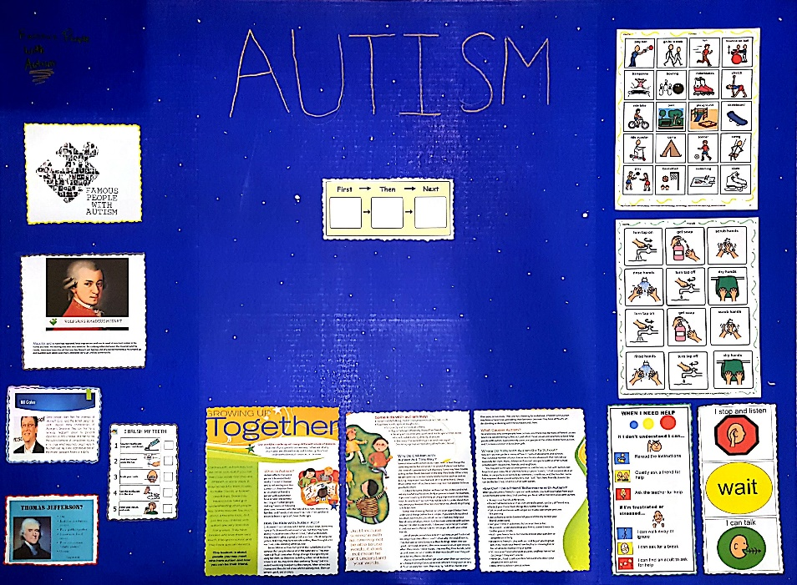
My experience with Autism:
I am a big sister to a child with autism. It can be challenging, there are good days and bad days, but for the most part good days. Sometimes it is difficult for her to express her feelings, so she cries and has meltdowns, but with the help of our therapist we are working on having her use her words. Therapy has helped with her behavior. She has learned coping skills to avoid her from screaming and crying. My sister has thought me how to be patient and kind. My sister at times can be stressful to deal with but she is so caring and loving that it makes it easy to look past that and enjoy her for what she is, a loving caring sister.
Activities: Art project
Art is a type of therapy. Children with autism can explore the feel and texture of materials. He or she might not actually want to create a work of art and that’s okay, the materials are used to help him or her relax and experiment.

Ten Things Every Child with Autism Wishes You Knew
By Ellen Notbohm, and reformatted by Isabella Maxwell
- I am a child.
My autism is part of who I am, not all of who I am. Are you just one thing, or are you a person with thoughts, feelings, preferences, ideas, talents, and dreams? Are you fat (overweight), myopic (wear glasses) or klutzy (uncoordinated)? Those may be things that I see first when I meet you, but you’re more than just that, aren’t you?
- My senses are out of sync.
This means that ordinary sights, sounds, smells, tastes, and touches that you may not even notice can be downright painful for me. My environment often feels hostile. I may appear withdrawn or belligerent or mean to you, but I’m just trying to defend myself. Here’s why a simple trip to the grocery store may be agonizing for me.
- Distinguish between won’t (I choose not to) and can’t (I am not able to).
It isn’t that I don’t listen to instructions. It’s that I can’t understand you. When you call to me from across the room, I hear “*&^%$#@, Jordan. #$%^*&^%$&*.” Instead, come over to me, get my attention, and speak in plain words: “Jordan, put your book in your desk. It’s time to go to lunch.” This tells me what you want me to do and what is going to happen next. Now it’s much easier for me to comply.
- I’m a concrete thinker. I interpret language literally.
You confuse me by saying, “Hold your horses, cowboy!” when what you mean is, “Stop running.” Don’t tell me something is “a piece of cake” when there’s no dessert in sight and what you mean is, “This will be easy for you to do.” When you say, “It’s pouring cats and dogs,” I see pets coming out of a pitcher. Tell me, “It’s raining hard.” Idioms, puns, nuances, inferences, metaphors, allusions, and sarcasm are lost on me.
- Listen to all the ways I’m trying to communicate.
It’s hard for me to tell you what I need when I don’t have a way to describe my feelings. I may be hungry, frustrated, frightened, or confused but right now I can’t find those words. Be alert for body language, withdrawal, agitation or other signs that tell you something is wrong.
- Picture this! I’m visually oriented.
Show me how to do something rather than just telling me. And be prepared to show me many times. Lots of patient practice helps me learn. Visual supports help me move through my day. They relieve me of the stress of having to remember what comes next, make for smooth transition between activities, and help me manage my time and meet your expectations.
- Focus and build on what I can do rather than what I can’t do.
Like any person, I can’t learn in an environment where I’m constantly made to feel that I’m not good enough and that I need fixing. I avoid trying anything new when I’m sure all I’ll get is criticism, no matter how “constructive” you think you’re being. Look for my strengths and you will find them. There is more than one right way to do most things.
- Help me with social interactions.
It may look like I don’t want to play with the other kids on the playground, but it may be that I simply do not know how to start a conversation or join their play. Teach me how to play with others. Encourage other children to invite me to play along. I might be delighted to be included. I do best in structured play activities that have a clear beginning and end. I don’t know how to read facial expressions, body language, or the emotions of others. Coach me. If I laugh when Emily falls off the slide, it’s not that I think it’s funny. It’s that I don’t know what to say. Talk to me about Emily’s feelings and teach me to ask, “Are you okay?”
- Identify what triggers my meltdowns.
Meltdowns and blow-ups are more horrid for me than they are for you. They occur because one or more of my senses has gone into overload, or because I’ve been pushed past the limit of my social abilities. If you can figure out why my meltdowns occur, they can be prevented. Keep a log noting times, settings, people, and activities. A pattern may emerge.
- Love me unconditionally.
Throw away thoughts like, “If you would just—” and “Why can’t you—?” You didn’t fulfill every expectation your parents had for you and you wouldn’t like being constantly reminded of it. I didn’t choose to have autism. Remember that it’s happening to me, not you. Without your support, my chances of growing up to be successful and independent are slim. With your support and guidance, the possibilities are broader than you might think. Three words we both need to live by: Patience. Patience. Patience. View my autism as a different ability rather than a disability. Look past what you may see as limitations and see my strengths. I may not be good at eye contact or conversation, but have you noticed that I don’t lie, cheat at games, or pass judgment on other people? I rely on you. All that I might become won’t happen without you as my foundation. Be my advocate, be my guide, love me for who I am, and we’ll see how far I can go.

Growing Up Together
Children with autism may look like other kids, but if you met them you would find they are different in some ways. It may be hard for them to play, to make friends or to learn new things. Some may have trouble talking or understanding what people say. Some may talk too much about a favorite topic. But, just like you, children with autism are very special in many ways. They have families who love them very much, they go to school, and they have special interest.

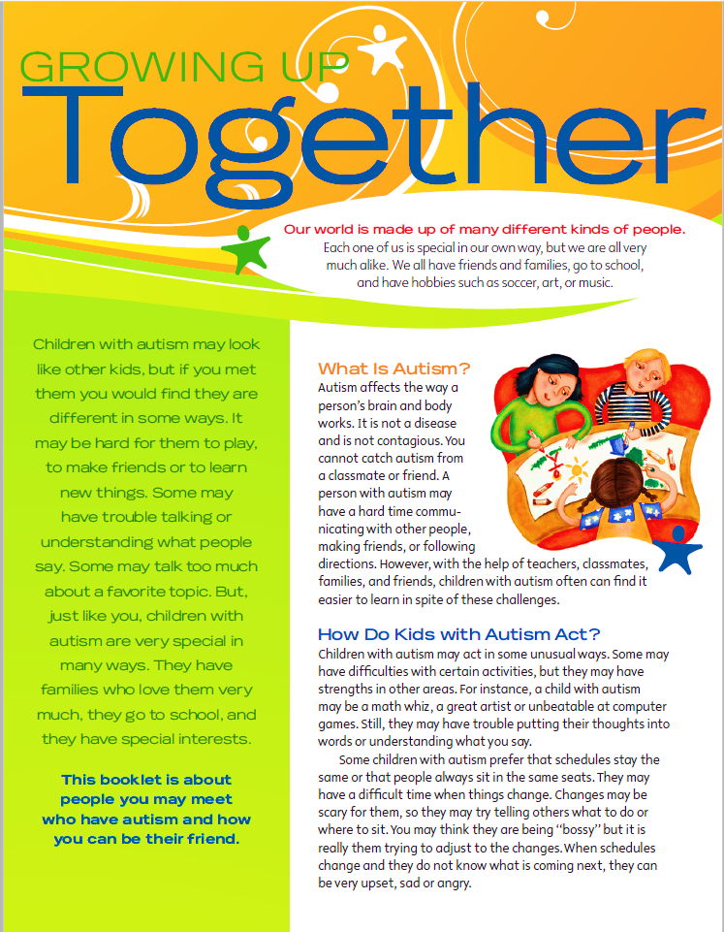

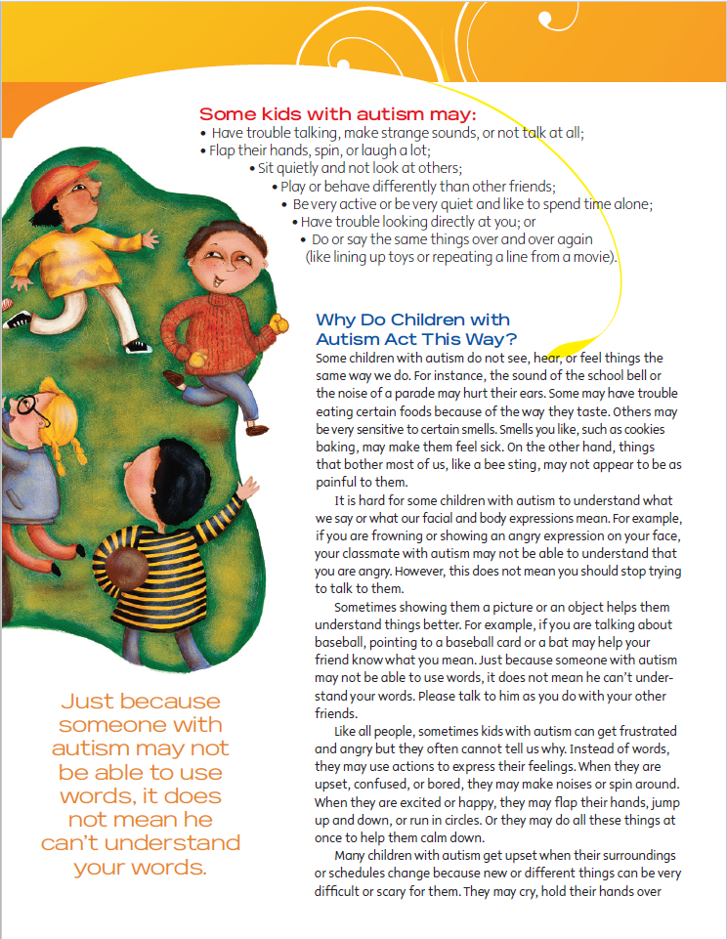

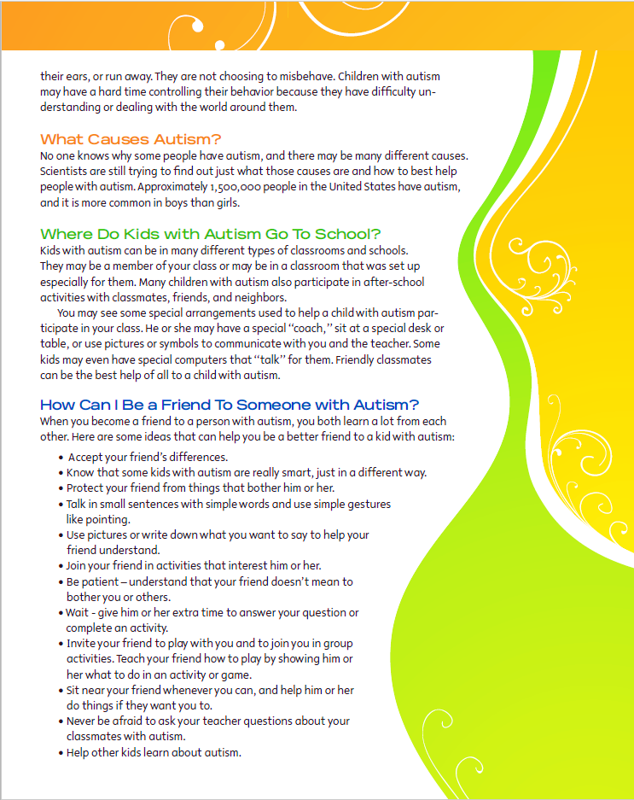

VISUAL IMPAIRMENTS

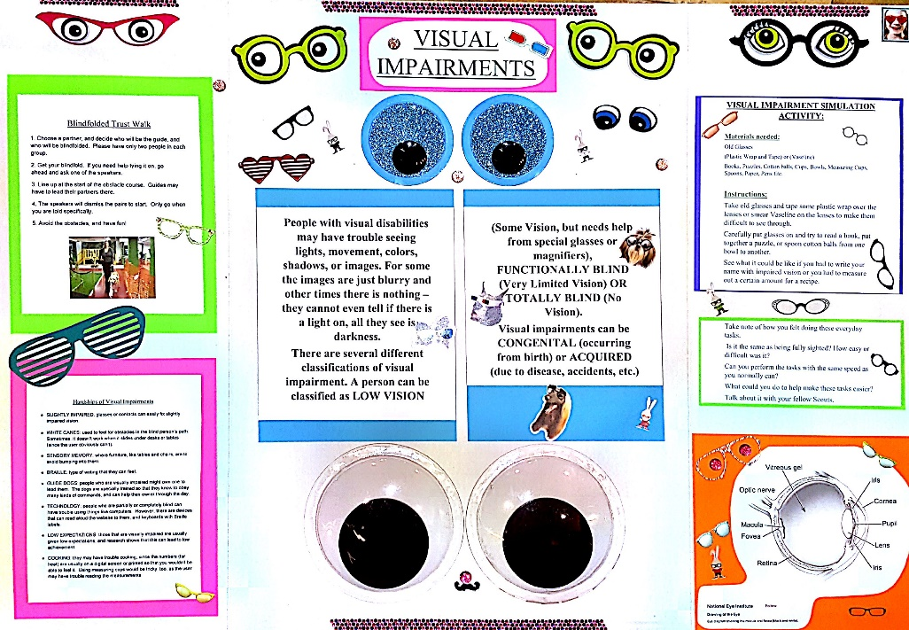
People with visual disabilities may have trouble seeing lights, movement, colors, shadows, or images. For some the images are just blurry and other times there is nothing – they cannot even tell if there is a light on, all they see is darkness.
There are several different classifications of visual impairment. A person can be classified as LOW VISION (Some Vision, but needs help from special glasses or magnifiers), FUNCTIONALLY BLIND (Very Limited Vision) OR TOTALLY BLIND (No Vision).
Visual impairments can be CONGENITAL (occurring from birth) or ACQUIRED (due to disease, accidents, etc.)
Visual Impairment Simulation Activity:
Materials needed:
Old Glasses
(Plastic Wrap and Tape) or (Vaseline)
Books, Puzzles, Cotton balls, Bowls, Spoon, Etc.
Instructions:
Take old glasses and tape some plastic wrap over the lenses or smear Vaseline on the lenses to make them difficult to see through.
Carefully put glasses on and try to read a book, put together a puzzle, or spoon cotton balls from one bowl to another. Take note of how you felt doing these everyday tasks. How easy or difficult was it? What could you do to help make these tasks easier? Talk about it with your fellow Scouts.

PHYSICAL DISABILITIES

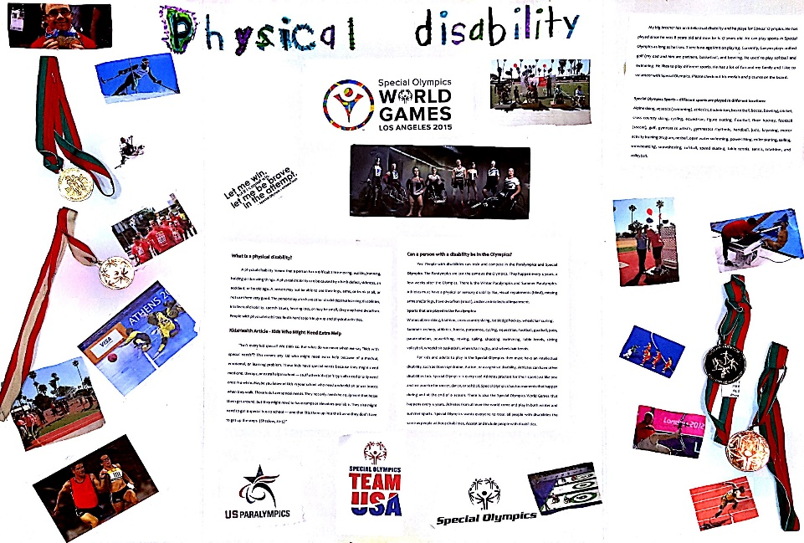
What is a physical disability?
A physical disability means that a person has a difficult time moving, walking/running, holding or throwing things. A physical disability can be caused by a birth defect, sickness, an accident, or by old age. A person may not be able to use their legs, arms, or trunk at all, or not use them very good. The person may also have other disabilities like learning disabilities, intellectual disability, speech issues, hearing loss, or may be small, they may have dwarfism. People with physical disabilities find it hard to join in group and physical activities.
KidsHealth Article - Kids Who Might Need Extra Help
“Isn't every kid special? We think so. But what do we mean when we say "kids with special needs"? This means any kid who might need extra help because of a medical, emotional, or learning problem. These kids have special needs because they might need medicine, therapy, or extra help in school — stuff other kids don't typically need or only need once in a while. Maybe you know of kids in your school who need a wheelchair or use braces when they walk. Those kids have special needs. They not only need the equipment that helps them get around, but they might need to have ramps or elevators available. They also might need to get a special bus to school — one that lifts them up into the bus so they don't have to get up the steps. (Sheslow, 2015)”
Can a person with a disability be in the Olympics?
Yes! People with disabilities can train and compete in the Paralympics and Special Olympics. The Paralympics are just the same as the Olympics. They happen every 4 years, a few weeks after the Olympics. There is the Winter Paralympics and Summer Paralympics. Athletes must have a physical or sensory disability like, visual impairments (blind), missing arms and/or legs, have dwarfism (small), and/or an intellectual impairment.
Sports that are played in the Paralympics:
Winter: alpine skiing, biathlon, cross-country skiing, ice sledge hockey, wheelchair curling.
Summer: archery, athletics, boccia, paracanoe, cycling, equestrian, football, goalball, judo, paratriatholon, powerlifting, rowing, sailing, shooting, swimming, table tennis, sitting volleyball, wheelchair basketball, wheelchair rugby, and wheelchair tennis.
For kids and adults to play in the Special Olympics they must have an intellectual disability, such as Down syndrome, Autism, or a cognitive disability. Athletes can have other disabilities too. Special Olympics is every day! Athletes practice for their sport just like you and me practice for soccer, dance, or softball. Special Olympics has tournaments that happen during and at the end of a season. There is also the Special Olympics World Games that happens every 4 years. Athletes from all over the world come and play in both winter and summer sports. Special Olympics wants everyone to treat all people with disabilities the same as people without disabilities. Accept and include people with disabilities.
Junior Girl Scout Kyra shared this information about her brother and Special Olympics.
My big brother has an intellectual disability and he plays for Special Olympics. He has played since he was 8 years old and now he is 17 years old. He can play sports in Special Olympics as long as he likes. There is no age limit on playing. Currently, Gavynn plays unified golf (my dad and him are partners, basketball, and bowling. He used to play softball and swimming. He likes to play different sports. He has a lot of fun and my family and I like to volunteer with Special Olympics. Please check out his medals and pictures on the board.
Special Olympics Sports – different sports are played in different locations:
Alpine skiing, aquatics (swimming), athletics, badminton, basketball, bocce, bowling, cricket, cross country skiing, cycling, equestrian, figure skating, floorball, floor hockey, football (soccer), golf, gymnastics artistic, gymnastics rhythmic, handball, judo, kayaking, motor activity training program, netball, open water swimming, powerlifting, roller skating, sailing, snowboarding, snowshoeing, softball, speed skating, table tennis, tennis, triathlon, and volleyball.
Work Out a Workout Simulation Activity:
Have girl choose an activity or game they play at recess or in physical education class and think of ways they would play these game with girls with different abilities. They can ask a knowledgeable adult who is familiar with disabilities, such as a physical or special education teacher, for ideas, or use the Girl Scouts game book and adapt a game.
Examples:
- Try shooting hoops while sitting. Sit in a wheelchair or a chair and try to make a basket by throwing a basketball into a hoop or large bucket.
- Make a guidewire system that encourages individuals with visual impairments or who are blind to participate in running activities. A guidewire system is a rope that is securely anchored to an eyehook or attached to poles. The rope can also be held at each end. Make sure when holding the rope to verbally tell the Girl Scout running to stop before they run into the Girl Scout holding the rope. Attach a PVC tube to the rope so the Girl Scout can hold the PVC tube and run along the rope. This allows the Girl Scout and visually impaired person to run freely and not be dependent on a sighted person. The Girl Scout running will need a blindfold to wear.
- Try kicking a soccer ball with only being able to use one leg. You will need a walker or cane and a soccer ball to accomplish this activity.
- Catch a ball with only one hand, and then throw it back to a partner.

HEARING DISABILITIES – COMMUNICATING

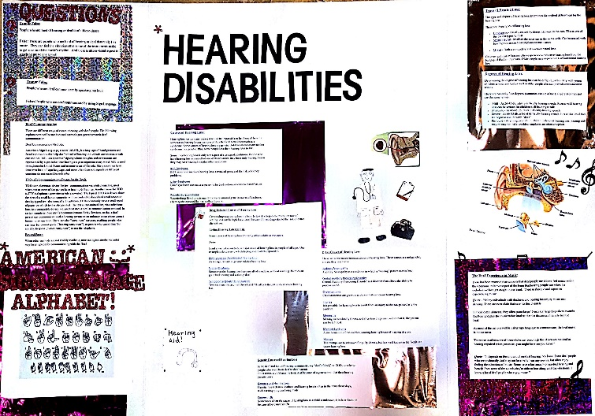
There are two parts to sounds. Loudness and pitch. Loudness ranges from soft to loud. Pitch ranges from high tones to low tones. Both loudness and pitch produce the sounds that we hear. Persons with hearing disabilities can range from mild to profound and can produce difficulties in communicating with others. Try this activity to simulate communicating with someone who cannot hear and understand speech.
Divide the girls into pairs. Give one girl in each pair a message to communicate to her partner without talking:
- Please get me a drink of water.
- Where is the restroom?
- Can I have something to eat?
- Can I have a tissue?
- Can you help me with my homework?
Questions to ask the group:
- How did they communicate? (Using eye contact, gestures, pointing to objects, writing, etc?)
- How did it feel to communicate silently?
Hearing Disabilities - Muffled Sounds
This activity will help girls to understand the frustration of not hearing clearly.
Ask for the girls to stay in their pairs. One girl will plug her ears with her fingers and her partner will quietly ask her a question(s). The girl who plugged her ears will attempt to answer the question(s):
- What is your name?
- How old are you?
- Do you have any pets?
- Do you have any siblings?
- How long have you been a Girl Scout?

Questions to ask the group:
- Ask the girls to share how it felt to have their hearing impaired.
- What are some things to remember when communicating with someone with a hearing disability?

Handout – American Sign Language Alphabet
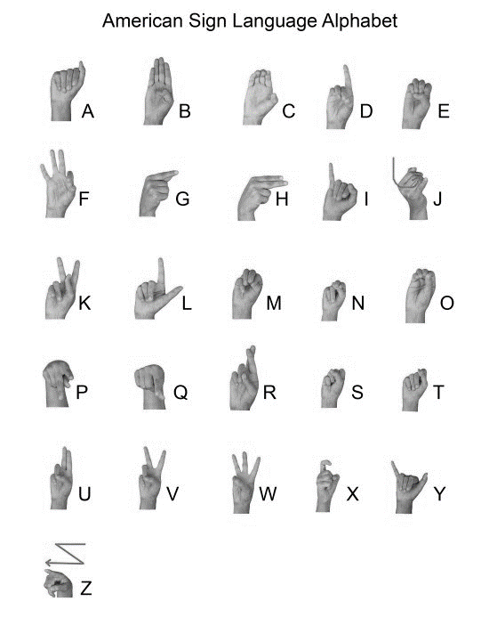

DISABILITY AWARENESS QUIZ

Answer with True (T) or False (F)
- You can “catch” a disability from someone else. ___
- People in wheelchairs cannot play sports. ___
- People who talk slow or have a learning disability are not smart. ___
- People with disabilities don’t have the same feelings as people without disabilities. ___
- People with disabilities cannot live by themselves. ___
- Everyone who uses a wheelchair is unable to walk. ___
- People who are blind must run with a person holding on to them. ___
- Athletes with disability cannot play in the Olympics. ___
- People who are deaf communicate by speaking out loud. ___
- People who are hard of hearing or deaf don’t like music. ___
- Children with autism cannot communicate or understand. ___
- Not all people with autism find eye contact difficult, but lots do. ___
- People with visual impairments cannot do everyday tasks. ___

Disability Awareness Quiz – Answer Key
- You can “catch” a disability from someone else.
False. A disability is not something that you can catch.
- People in wheelchairs cannot play sports.
False. Almost every sport you can think of has been adapted so that people in wheelchairs can play! From wheelchair basketball, to sled hockey, to rugby!
- People who talk slow or have a learning disability are not smart.
False. Just because somebody has problems vocalizing their thoughts or processing certain kinds of information does not mean that they are not smart.
- People with disabilities don’t have the same feelings as people without disabilities.
False. Everyone has feelings.
- People with disabilities cannot live by themselves.
False. There are many people with disabilities who live independently. There are also many people that live by themselves but may have someone help them with more difficult tasks.
- Everyone who uses a wheelchair is unable to walk.
False. Many people are in wheelchairs because their legs are too weak to carry them long distances. They may walk for short distances or just for exercise, while some people who use wheelchairs are unable to walk.
- People who are blind must run with a person holding on to them.
False. People who are blind use a guide wire to run.
- Athletes with disability cannot play in the Olympics.
False. There is Special Olympics world games for people with intellectual disabilities. Paralympics is for people with physical disabilities. Both happen every four years like the Olympics.
- People who are deaf communicate by speaking out loud.
False. People who are deaf communicate by using Sign Language.
- People who are hard of hearing or deaf don’t like music.
False. There are people who are hard of hearing or deaf that really like music. They can feel the vibrations that some of the instruments make to get a sense of the music’s rhythm. And there is also a visual aspect to watching musicians as well.
- Children with autism cannot communicate or understand.
False.
- Not all people with autism find eye contact difficult, but lots do.
True.
- People with visual impairments cannot do everyday tasks.
False. They can do everyday task. They just have to make adjustments and modifications to help them perform them. They can use their other senses like touch to read Braille or hearing to listen for auditory clues.

LOCAL RESOURCES

Learning Disabilities
Learning Disabilities Association of America
ldaamerica.org/types-of-learning-disabilities/
National Center for Learning Disabilities
www.ncld.org/
Physical Disabilities
Ventura County Special Olympics
1559 Spinnaker Dr. #206
Ventura, CA 93001
Phone: 805/650-7717
website: www.specialolympics.org
U.S. Paralympics
www.teamusa.org/us-paralympics
Disabled Sports USA
www.unrecables.com/
Ventura County Special Education Local Plan Area
https://www.vcselpa.org/Our-SELPA/Local-Plan

