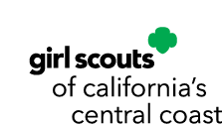

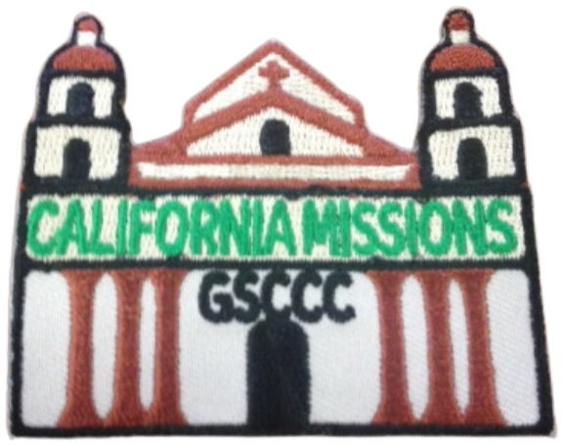

California Missions
Council's Own Patch Program

Step into California’s past and explore the history of the Spanish Missions in our Council area. Discover mission architecture, foods, crafts, music and daily life, while also learning about the experiences of Native Americans and the complex role the Missions played in California history.

Once you complete the curriculum, please purchase your patch through DoubleKnot
Patch cost $5.00 includes shipping.

DISCOVER

Explore California Mission History
California's Missions tell an important—and complicated—part of our state's history. Discover why the Missions were established, how people lived and worked there, and how the Mission system affected the Native peoples who had lived in California for thousands of years before Spanish colonization.
Complete three (3) or more of the following activities.
- Meet the Missions
Discover the Spanish Missions located within the GSCCC Council area. Find each one on a map and learn when it was established, who established it, the origin and meaning of its name, and which Native peoples lived in the surrounding area before and during the Mission period.
- Before the Missions
Choose one of the Native peoples whose ancestral homeland includes an area where a California Mission was established. Learn about their community before the Mission period, including language, foods, homes, traditions, trade, relationship with the land, and ways of life. Whenever possible, use resources created or recommended by the Tribe or Indigenous community you are learning about.
- Why Were Missions Built?
Investigate why Spain established Missions in California. What roles did Missions, presidios and pueblos play in Spanish colonization? Why were Native Californians brought into the Mission system? How did Mission life affect their traditional communities, cultures and ways of life?
- Mission Life: Different Perspectives
Learn about several people who might have lived at or interacted with a Mission—such as a Native Californian, Spanish missionary, soldier, settler or child. How might their experiences have been different? What choices and freedoms did each person have?
- Explore Mission Architecture
Discover how Missions were designed and built. Learn about adobe construction, courtyards, churches, workshops, gardens and other features. Draw a Mission floor plan, build a small model, or try making a few miniature adobe bricks.
- Food Then & Now
Investigate foods eaten in California before and during the Mission era. Which foods were traditionally used by Native Californians? Which plants, animals or cooking traditions arrived with Europeans? Prepare a food or recipe inspired by something you learned.
- Sounds of the Missions
Explore the role of bells and music at the Missions. What purposes did bells serve? Learn about music from the Mission era and investigate the role Native musicians played in Mission musical traditions.
- History Detective
Choose two sources that describe California Mission history—perhaps a Mission website, museum, book, Tribal resource or historical organization. Do they tell the story in the same way? What does each emphasize or leave out? Why is it important to look at history from more than one perspective?

CONNECT

Experience Mission History
History becomes much more meaningful when you can see the places, objects and stories connected to it. Visit historic sites and museums, meet people who study California history, and discover how the Mission era continues to be interpreted today.
Complete two (2) or more of the following activities.
- Visit a California Mission
Visit at least one Mission in the GSCCC Council area. Take a guided tour when available. Explore the buildings, grounds, exhibits and artifacts. As you explore, consider:
  - Whose stories are being told? What do you learn about Native Californians? What evidence of daily life can you find? What questions do you still have after your visit?

- Compare Two Historic Sites
Visit two Missions—or a Mission and another California history site—and compare them. What is similar? What is different? How does each location interpret California history?
- Connect with Indigenous History
Learn directly from a local Tribe, Tribal museum, cultural center, Indigenous educator, cultural program or Tribe-created educational resource. Discover how Native communities tell their own history and how they continue to preserve their languages, traditions and cultures today.
- Meet a History Keeper
Talk with a historian, archaeologist, museum educator, park interpreter, archivist, Tribal cultural educator or another person who helps preserve and interpret California history. Ask how we know what happened in the past and why our understanding of history sometimes changes as we discover new information and listen to different perspectives.
- Artifacts Tell Stories
At a Mission, museum or online collection, choose several historical objects. What were they used for? Who might have made or used them? What can the objects tell you about people's everyday lives?
- Then & Now
Find historic photographs, drawings or maps of a Mission or surrounding community and compare them with what the area looks like today. What has changed? What remains?

TAKE ACTION

Help Preserve & Share California's History
You've explored California's Mission history from multiple perspectives. Now use what you've learned to help others better understand, appreciate and preserve California's history and cultures.
Complete two (2) or more of the following activities.
- Tell the Whole Story
Create a poster, presentation, exhibit, video, booklet, timeline or other project about California Mission history. Include multiple perspectives and make sure Native Californians are represented as people with cultures and communities that existed before, during and after the Mission era—and continue today.
- Become a Junior Historian
Choose a historical question that interests you and investigate it using several reliable sources. Share what you discovered with your troop, family, school or community.
- Create a Mission History Guide
Create a kid-friendly guide for visiting one of the Missions. Include interesting things to look for, questions visitors can ask and information about the Native peoples whose ancestral homeland includes that area.
- Preserve a Piece of History
Contact a Mission, museum, State Historic Park, historical society, Tribal cultural organization or other appropriate organization and ask whether there is a service project Girl Scouts can help with. Let the organization identify what would actually be useful.
- Share Indigenous History
With guidance from reliable, preferably Tribe-created or Tribe-approved resources, help others learn something you discovered about the Native peoples connected to your area. Focus on both history and contemporary communities.
- Protect a Historic Place
Learn what threatens historic or culturally significant places—weather, erosion, development, vandalism, climate change or simply the passage of time. Find an appropriate way to support preservation or educate others about why these places matter.
- History in Your Own Community
The Missions aren't the only places where California history happened! Find another historic or culturally significant site near you. Learn its story and find a way to share or help preserve it.

