

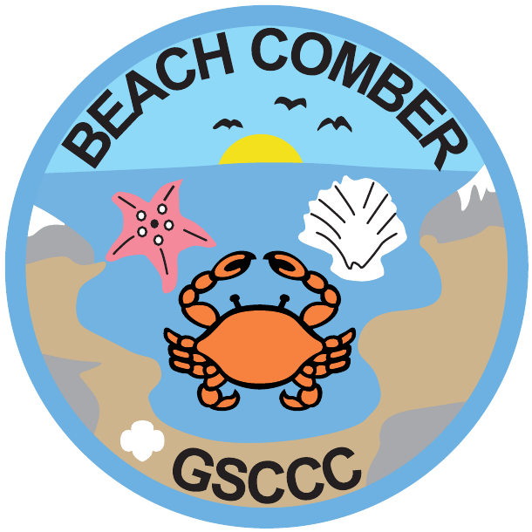

Beachcomber
Council's Own Patch Program
Explore the wonders of California’s coastline and discover what makes our beaches, tide pools and coastal habitats so special! Learn about the plants and animals that call the seashore home, investigate the challenges facing our oceans, and discover how you can help protect these fragile environments.

Once you complete the curriculum, please purchase your patch through DoubleKnot

Patch cost $5.00 includes shipping.

This patch program has been designed to educate the participants about exploring and discovering our local beaches and seashores to uncover some of the secrets of these unique and diverse habitats.
You will explore and investigate your local shoreline through printed materials found within this patch program. Learn the importance of preserving our fragile shorelines and identify the unique fauna of the tide pools.

To earn this patch, please complete the following number of items from each section:

 | Discover | Connect | Take Action
Daisy | 1 | 1 | 1
Brownie | 2 | 1 | 1
Junior | 2 | 2 | 1
Cadette | 2 | 2 | 2
Senior | 3 | 2 | 2
Ambassador | 3 | 3 | 2

DISCOVER YOUR SEASHORE

1. Discovering the seashore: choose ONE of the following activities
- Take a beach walk at low tide; write down your discoveries.
  - Return a second time to the same beach. How is it the same? How is it different?
- Make a collection of non-living objects to exhibit and share. (Remember, sometimes shells appear empty, when there is a living creature hidden deep inside! Be sure that there is nothing living in any shells you collect.)
- Observe TWO of the following:
  - A sea anemone open, closed, and closing when touched
  - A crab scuttling
  - A starfish clinging tightly to a rock
  - A shore-bird feeding
  - A brown pelican diving
  - A sea hare “inking” a pool of water
- Explore two different kinds of beach and note your findings (sandy vs. rocky). Learn how sandy beaches change in size and shape according to the seasons; find out differences between a rocky and sandy shore.
2. Tide pools
- Learn how to read a tide table. You can find an interactive online tide table here. Find out where and when to obtain a printed tide table and what you can learn from them to make your beach visits as interesting as possible. Be able to explain “minus tide” and “tide pools” and what causes tidal action.
3. Shells & Tide pool Animals
- Find 5 different kinds of shells and 5 different live animals in the tide pools and “splash” zone
- Sort shells into categories by shape
- Explain what a “shell” is
- Try to find at least one beach or tide pool animal that has jointed legs; one that is attached to a rock; and one whose two-parted shell is hinged
- Note which tide pool animals live together, which ones are exposed to air more frequently and which ones are seen only at very low tides. Think of some reasons why various animals look different and why this may help them to survive
4. Kelp & Algae
- Learn the 3 different kinds of “seaweed,” or marine algae
- Define “marine algae”
- Be able to identify giant kelp
- List one or more ways humans use seaweed
5. Birds: choose ONE of the following activities
- Seashore birds (If possible, visit a bird rookery along the ocean or bay). Learn to recognize:
  - 1 duck
  - 1 shorebird
  - 1 long-legged wading bird
  - 1 skydiving bird
    - Note where and when you found each bird and try to find out what it eats
- Learn about nesting habitats for local birds, and what humans can do to help protect nesting birds and nesting habitats
- Learn about the different kinds of beaks found on seashore birds, and how beak shape is related to the type of food the bird eats. Then observe some birds in the wild and try to predict their favorite foods.
6. Marine mammals: choose ONE of the following activities
- Find out something about marine mammals along our coast. Which mammals do we have in our area and their habits in general, including diet and defense behaviors to protect themselves against predators
- Or… Go whale watching by boat or observe them from the shore and write about your experience
- Or… Visit an aquarium or zoo which has marine mammal tanks and write about your experience
7. Animal Tracks & Plant Pressing: choose ONE of the following activities
- Make a plaster cast of a bird or animal track on the beach or along the bank of an estuary. There are many great resources for learning how to make a plaster cast on the internet (make sure you have an adult helping you look this up).
- OR - press 2 or more different kinds of seaweed. Directions for how to press seaweed can be found here.
8. Beach/Dune Plants
- Visit a salt marsh, slough, or sand dune habitat to discover the diversity of plants that grow on the sand dunes or the coastal strand along the salt marsh.
- Learn to recognize 3 dune or salt marsh plants
- Learn what conditions they face and how you think they have adapted to this environment
- Learn why dunes are so fragile, and the importance of the native plants to preserving these unique environments.

CONNECT TO YOUR COASTLINES

1. The Seashore and the Arts: Choose ONE of the following activities
- Create an art or craft activity related to the seashore
- Write a poem that expresses how you feel about the ocean or seashore
- Choose a seashore poem to share with your family or your troop
- Learn a song related to the ocean or seashore to share with your family or your troop
- Discover and share several ways in which seashells are used in design, decorative art, architecture, or fine art
- Read a children’s book about the ocean or seashore and share with your family or your troop
2. Visit at least ONE of the following:
- Visit a Museum of Natural History to explore exhibits such as seashore habitats, bird life, marine life, and/or identified shell collections
- Visit a Marine Biology Laboratory
- Visit a big aquarium
- Attend a Malacological Society Shell Show
3. Contact a local State Park, National Park, or County Park, and do one of the following:
- Discover the history of the park. When was it founded? Why was the area protected? What kind of natural resources are being protected there? What kind of recreational opportunities are available?
4. Watch a film or TV show about the ocean
- Work with your parents to find a film or educational TV show related to the ocean (there are many educational TV stations to choose from, and a long list of documentaries available on entertainment sites such as Netflix). You can also check DVDs out of many libraries.
- Share what you have learned about the ocean with your family or your troop
5. Find out about urban runoff
- Do some research to learn what “urban runoff” and “nonpoint source pollution” are.
- Determine ways that you and your household can help limit urban runoff.
6. Discover how the world’s oceans are connected.
- Do some research to learn about the Great Pacific Trash Gyre (also called the Pacific Garbage Patch).
- Learn about how waste discarded here can end up there.
- Discover why scientists and activists are worried, and what the major component of all that trash is.

TAKE ACTION FOR YOUR ENVIRONMENT

1. Environment of the seashore and ocean
- Learn about the major State and Federal laws that protect marine life
- Understand what kind of care everyone visiting a beach should exercise to protect marine life and our oceanfront habitats
2. Health and Safety
- List main safety rules for exploring the seashore and be able to explain them to others using a poster or by acting out a skit.
  - Include how to appropriately prepare and dress to visit the seashore
    - Don’t forget the sunscreen!
  - Include how to treat plants and animals encountered at the seashore
3. Engage in education.
- Take what you have learned by earning this patch and use it to educate others. Choose ONE or more of the following activities:
  - Hold a workshop in your community
  - Create posters and use them to raise awareness about an ocean-related issue that concerns you
  - Encourage people you know to pledge to use reusable shopping bags instead of single-use plastic bags
  - Start an Ocean or Environmental Club at your school, and rally other students to get involved with ocean issues
  - Make a short film about an issue of your choice
  - Familiarize yourself with “safe” seafood choices to help sustain healthy oceans and share this information with seafood lovers you know. Click here for more information.
4. Service: choose ONE of the following activities
- Participate in (or organize) a beach clean-up. These do not have to be large events; every little bit helps! (Make sure to wear gloves and never pick up anything dangerous!)
- Participate in (or organize) an inland trash clean-up. Much of the trash you see on the beach started in inland communities. These do not have to be large events; every little bit helps! (Make sure to wear gloves and never pick up anything dangerous!)
- Contact a local agency (county, state or federal) to determine if there are any projects underway that need your assistance. Sometimes, these agencies are eager to connect with young people to educate them, and they could have a campaign they would like to involve you in.
- Find out about a local issue affecting your coastline and write a letter to an elected official urging action on the issue.
- Investigate whether an ocean-related issue is coming up for a vote in your community and attend the meeting and speak out!

