

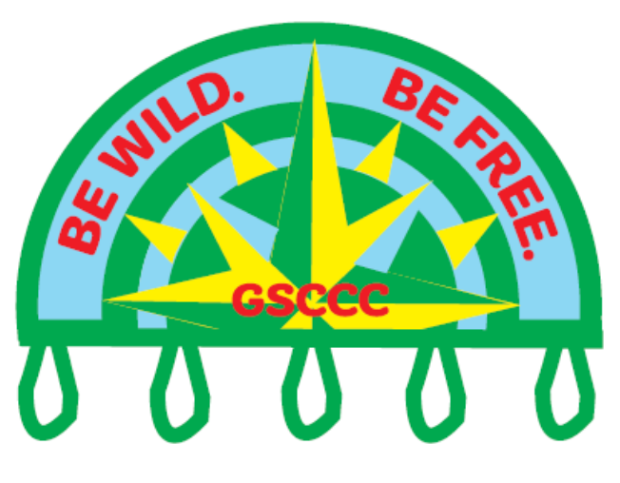

Be Wild. Be Free.
Council's Own Patch Program

Build the skills and confidence you need to enjoy the great outdoors! Learn the basics of camping, outdoor safety, knots, fire building, cooking, navigation and caring for the environment, then continue your adventure by mastering new outdoor skills and earning charms along the way.
The first step to begin earning the Be Wild Be Free Skills charms is to earn the outdoor skills patch by completing the “basic 8” camping skills. Girls can then begin earning the outdoor skills charms.

Once you complete the curriculum, please purchase your patch through Doubleknot.
Patch cost $5.00 includes shipping.

How to earn the Outdoor Skills Patch:
In order to earn the outdoor skills patch, girls must complete the “basic 8” camping skills. They are as follows:
THE BASIC 8 CAMPING SKILLS

- Practice Good Outdoor Manners: Learn how to have the minimum amount of impact on your environment when in the outdoors.
- Describe your environment. What does it include? What do you see, hear, smell?
- Discuss with your troop, what good outdoor manners mean.
- Leaving your litter behind is not considerate to other visitors and it is hazardous to animals. Examples of hazards are chewing gum gets stuck in fur, cans and bottles can cut the animals. Can you think of other hazards?
- The outdoors is home to many of our animal friends. We may watch them, but we should not disturb them or destroy their homes. Find out why human food isn’t healthy for wild animals. What are the effects of trash carried by the wind? How does this impact animals and the environment?
- Maybe include an area clean-up time at the end of your activity.
*A Girl Scout always leaves a place better than she found it! *
Understand and practice this concept at every meeting. It is a girl scout tradition. It is not just practiced in Girl Scouts but in all we do.
- Proper Clothing: With your troop, decide on the proper clothing for various outings.
- How do you dress for different situations: a day at the beach, a rainy hike, a windy bike ride, a summer picnic, etc. How about planning clothing for an overnight? How would the clothes be different for different places you might spend the night?
- Discuss sunscreen, proper shoes, sleeve length and hats. Why are these items important? Be sure you know the appropriate attire for different activities- closed toe shoes, longer shorts or pants, etc. and the reasons we wear these. Understanding the safety reasons will help you remember the rules.
- Knots: Have a basic understanding of knots and their uses. Why are they important?
- An overhand knot is a stop knot. Find out how it is used. Have you ever used one? (Hint: if you’ve tied your shoes, you have!)
- A square knot is used to join 2 ropes of the same thickness. Practice tying and releasing the knot until you can do it fairly fast
- Learn how to coil your ropes after use to keep them untangled.
- Pocketknives: Understand how to keep safe when using a knife or other sharp object. Knives are weapons and can be dangerous.
- An “Arc of Safety” or “Safety Circle” is keeping an arm’s length away from anyone or anything. Measure this arc before having a knife in hand. Keep safety in mind when using a cutting tool of any kind. Have a knowledgeable adult demonstrate this, then try it yourself.
- It is always important to follow the safety rules when using paring knives in cooking and food preparation. They are small knives but are still dangerous.
- Cut away from your body and always use a cutting board. For younger girls or first timers, practice cutting softer foods like mushrooms or strawberries. This may seem simple, but it’s important to build your confidence with a knife for more difficult tasks later.
- *Daisies and Brownies: you may not be strong enough to open a pocketknife, but you should learn to handle it correctly. Making a paper knife can be a good way to practice pocket knife safety without accidents. Ask an adult for assistance if necessary.
- Camp Fire: Know basic fire safety rules. This will assist greatly later when you are actually building fires and cooking. Fire safety should be second nature to all Girl Scouts.
- When choosing and preparing fire building sites, keep these points in mind
- Check for fire permit requirements (leaders should do this.)
- Since fire burns upwards, check that there are no low or overhanging branches
- Only build fires in designated areas or pre-existing fire rings, fireplaces, elevated charcoal stoves, etc.
- Rake out 15 feet from the fire area, in all directions, down to the mineral level. That means no leaves, dry grass, twigs, pine needles, etc. – just dirt and/or sand
- Before starting your fire, place a metal bucket of water and a shovel near the fire circle
- Hair should be tied/pulled back with a bandana. This also keeps hair out of food when girls are preparing and cooking.
- Never wear nylon while near a fire of any kind. Tuck in all lanyards, name tags, hoodie cords, etc.
- Horseplay or running should never happen near a fire.
- Know the 3 parts of a fire and what their position in the fire is.
- Tinder: the “fluffy stuff” Tinder is what will catch fire and burn quickly. Usually, it consists of dry grass or leaves.
- Kindling: small sticks. Kindling is what the tinder lights. When your kindling catches fire, your fire is burning.
- Fuel: Fuel is larger wood and logs. These will burn a long time and will be where the bulk of the heat from your fire comes from.
- Cooking: Learn and establish good habits regarding handwashing and meal preparation.
- The importance of handwashing. To avoid illness, it is important to wash your hands before preparing food, before eating, and after using the restroom.
- Why should fruits and vegetables be washed before eating?
- Discuss food allergies. Why is it important to know if someone cannot have a certain type of food? Does anyone in your troop or family have an allergy. How might this affect your planning of meetings, outings, and trips?
- Learn how a bandana can be helpful in food preparation. (tying back hair, use as a napkin, etc.)
- Make a no-cook meal
- Make individual sandwiches or one great big long one and cut it into individual serving pieces
- Make friendship salad, where each girl brings a fruit to be cut up and added.
- Make pudding cones made with instant pudding in a plastic bag for a no-mess desert
- Staying Safe: Learn the importance of preventing accidents and what should be included in a basic first aid kit
- With your troop or family, talk about safety and why we have rules. “Walking in camp” is a good safety rule because running can lead to falls and scraped knees. (It is important to keep all rules positive so girls are aware of the behavior you are looking for. Ex: “Watch wildlife from a distance.” vs. “Don’t touch wild animals!” The former is proactive; the latter is reactive)
- Learn what the buddy system is and how it keeps girl scouts safe.
- Soap and water washing will take care of most minor cuts and skinned knees. Even bee stings can feel better once they’ve been cleaned with soap and water.
- Start assembling a small basic first aid kit for each person’s backpack. Everyone will feel better knowing they have the tools they need to fix their own scrapes.
- This is a great time to have a certified trained first-aider or medical professional talk to your troop about safety.
- Compass: Understand the uses of a compass and why one is important to backpackers and hikers. Even daisies can learn the basic cardinal directions. Know what to do when they are lost.
- Discuss the 4 cardinal directions. What are different ways to find North. Why is “finding north” important when you’re lost?
- Discuss what to do if you are separated from the group and lost. Discuss what to do if they realize their friend is separated from the group. With your troop or family, role play what to do if you’re lost. This can help everyone understand the reasons behind the rules.

EARN OUTDOOR SKILLS CHARMS

Patches may be ordered on Doubleknot.
Now you’re ready to earn some charms! Find charm requirements and purchase links below — click a charm name to view its product page.

SWAPS (D/B/J/C/S/A | Dutch oven Cooking (D/B/J/C/S/A)
Daisy (D/B) | Knots (D/B/J/C/S/A)
Girl Scout Traditions (D/B/J/C/S/A) | Lashing (J/C/S/A)
S’mores (D/B/J/C/S/A) | Tent Camping (D/B/J/C/S/A)
Water (D/B/J/C/S/A) | Compass (D/B/J/C/S/A)
Leave No Trace (D/B/J/C/S/A) | Geocaching (J/C/S/A)
First Aid (D/B) | Archery (J/C/S/A)
First Aid (J/C/S/A) | Knives (B/J/C/S/A)
Fire (D/B/J/C/S/A) | Cabin Camping (D/B/J/C/S/A)

